RSA Operations Console
Gibraltar

User Interface Specification

Migration

Work-in-progress | Draft for comment | Proposed for approval | Approved
Table of Contents

Revision History 3
Common Elements 4
Main Menu – Outline 4
Individual Page Specifications 5
1.1 Import Migration Package 6
1.1.1 Import Migration – Master Password Error 9
1.1.2 Import Migration – Multiple Package Files 11
1.1.3 Primary re-import refresh option 13
1.2 Migration Package Confirmation 15
1.3 Import Progress (for primary migration) 17
1.4.1 Import Progress with exceptions (for primary migration) 20
1.4.2 Import Progress (for replica migration) 23
1.5 Import Results – Happy path (for primary migration) 24
1.6 Import Results – With Warnings (for primary migration) 27
1.7 Import Results – Happy path (for replica migration) 29
1.7.1 Import Results – completed with errors (for replica migration) 31
1.8 Sample Migration Report – Primary Import 33
1.9 Sample Migration Report – Replica Import (if successful) 38
2. Migration from version 6.1 – Server Database 40
2.1 Locate Files 40
2.2 Scan Results 43
2.3 Customize Migration 46
2.4 Upload Sync Job Files 51
2.5 Map Directory to Identity Source 53
2.6 Summary (For Typical Mode) 56
2.7 Summary (For Custom Mode) 59
2.8 Summary (For Rolling Upgrade Mode) 63
2.9 Migration Status 65
2.10 Migration Results 67
2.11 Test Migration Status 69
2.12 Test Migration Results 71

Main Menu – Outline

Home
Deployment Configuration >
Migration >
From Version 7.1>
Import 7.1 Migration Package
Progress Monitor
From Version 6.1>
Server Database
Log Database

Individual Page Specifications
This section of the Specification provides a detailed account of each of the pages outlined in the Product Structure section. Each Page Specification is labeled with the outline number and page name as defined in the Product Structure.

The screenshots included in each page specification may be slightly out of date from the information that follows. In all cases the information provided in the specification supersedes the information in any given screenshot.

Import Migration Package

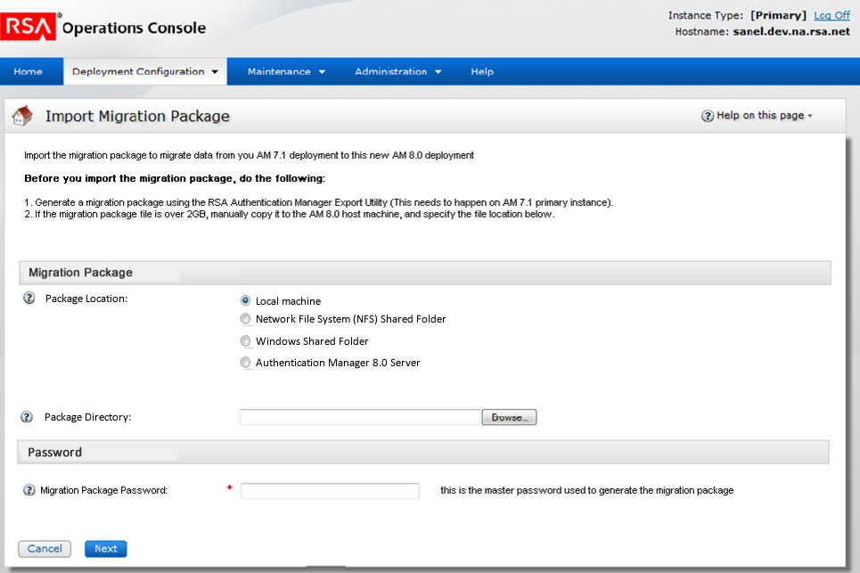

Status: Ready for Test
Revision Date | Description | Revised By
03/21/12 | Initial Draft | Dip Roychowdhury
05/18/12 | Added the options for NFS and winshare | Dip Roychowdhury

RSAPageHeaderTab

headerImage | Icn_importpkg.gif
headerText | Import Migration Package
introText | Import the migration package to migrate data from your RSA Authentication Manager 7.1 deployment to RSA Authentication Manager 8.0.  Before you import the migration package, do the following:  1. On the Authentication Manager 7.1 instance, generate a migration package with the RSA Authentication Manager 7.1 Migration Export Utility.  2. If the migration package exceeds 2GB, manually copy the package to an NFS or Windows shared folder  or the Authentication Manager 8.0 virtual appliance, and specify the file location on this page.
Required Field Note? | Y

Form Area

RSAGroupHead | Migration Package

Label | Package File Location | Component | RSAMultiRadios
Required? | Y | Enabled? | Y
Options | Local Machine  Windows Shared Folder  NFS (Network File System) Shared Folder  Authentication Manager 8.0 Server | Format | 4 Radio Buttons with show/hide options populating fields below each choice
 | The radio buttons will default Local Machine by default
iHelp | The location of the migration package that you generated on an instance in AM 7.1.

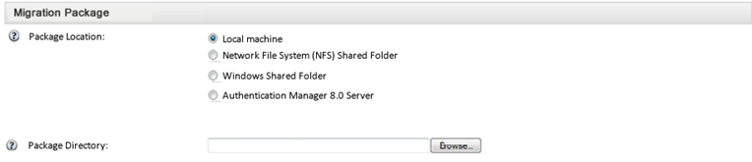

 | Label |  | Local Machine |  | Component | RSAMultiRadios
 | Required? |  | Y (One of the 3 buttons must be chosen) |  | Enabled? | Y
iHelp |  | No
Label |  | Select Package File |  | Component |  | RSATextField
Required |  | Y |  | Enabled? |  | No
Value |  |  |  | Format |  | Normal
iHelp |  | The location of the migration package that you generated on an instance in AM 7.1.

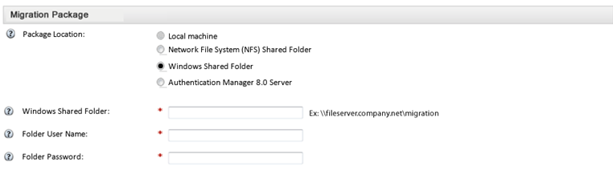

Label | Windows Shared Folder | Component | RSAMultiRadios
Required? | Y (One of the 3 buttons must be chosen) | Enabled? | Y
Value | [user selection of radio button]
Label | Windows Shared Folder | Component | RSATextField
Required | Y | Enabled? | Y
Value | [user input] | Format | <integer/char>
I-help | The hostname or IP of the windows shared folder, followed by the path where the migration package is stored.
Post label | Ex: \\example.com\migration_folder | Format | Read Only text
Label | Folder User Name | Component | RSATextField
Required | N | Enabled? | Y
Value | [user input] | Format | <integer/char>
I-help | User Name required to access shared folder.
Label | Folder Password | Component | RSATextField
Required | N | Enabled? | Y
Value | [user input] | Format | Password
I-help | Password required to access shared folder.

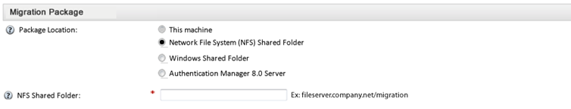

Label | NFS (Network File System ) Shared Folder | Component | RSAMultiRadios
Required? | Y (One of the 3 buttons must be chosen) | Enabled? | Y
Value | [user selection of radio button]

Label | NFS Shared Folder | Component | RSATextField
Required? | Y | Enabled? | Y
Value | [user input] | Format | <Integer/char>
Post label | Ex: fileserver.company.net/migration | Format | Read Only text
iHelp | The host name or IP address of the NFS server, followed by the path where the migration package is stored.

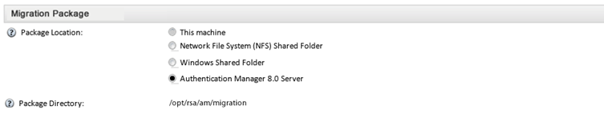

 | Label |  | Authentication Manager 8.0 Server |  | Component | RSAMultiRadios
 | Required? |  | Y (One of the 3 buttons must be chosen) |  | Enabled? | Y
iHelp |  | No
Label |  | Package Directory |  | Component |  | RSATextField
Required |  | N |  | Enabled? |  | Y
Value |  | <directory path is whatever the system defines as a place for the migration pkg to go> on the appliance example it’s usually: /opt/rsa/am/ |  | Format |  | Read only
iHelp |  | Your migration package is stored in this location.

RSAGroupHead | Password

Label | Migration Package Password | Component | RSATextField
Required? | Y | Enabled? | Y
Value | [User entry] | Post Label
Hint | The password used to encrypt the migration package from version 7.1

RSAButtonRow – Bottom only
Button Name / Style | Action | Title
Cancel / button_lt | Discard changes, go to OC home page. | Cancel
Next/ button_rt | Go to the migration confirmation screen  Unless they are importing from a 7.1 primary again, in which case go to the “primary re-import refresh option” screen | Next

Page Specific Error Handling & Messages
Condition | Page top message | Field(s)
If Migration Package Master Password is wrong. | [Show master password error with migration pkg already uploaded scree, see below]
Upload option is chosen and admin didn’t browse to an appropriate file | Specify the location of the migration package.
The nfs or winshare location is incorrect format or doesn’t exist | The specified location is invalid.
No package found error message | The specified location does not contain a migration package file.
If uploaded pkg is not with a .pkg extension | The specified file is not a migration package. The migration package should have a .pkg extension.

Help on this page
Help topics | Link

Next steps | Link

Import Migration – Master Password Error

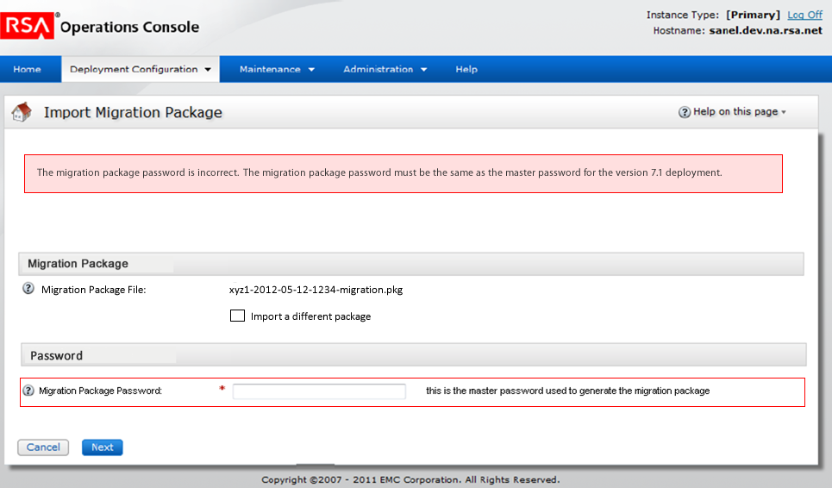

Revision Date | Description | Revised By
05/18/12 | Initial Draft | Dip Roychowdhury

RSAPageHeaderTab

headerImage | Icn_importpkg.gif
headerText | Import Migration Package
introText | NA
Required Field Note? | Y

Error Message: “
The migration package password is incorrect. You must enter the password that was used to encrypt the migration package in version 7.1.

”

Form Area

RSAGroupHead | Migration Package

Label | Migration Package File | Component | RSA Text Box
Required? | NA | Enabled? | Y
Readonly | Y
Value | [Filename of the pkg already uploaded]
Hint | File name of the migration package file to be imported.

Label | NA | Component | RSA CheckBox
Required? | N | Enabled? | Y
PostLabel | Import a different package
Default | unchecked
Hide/Show | When checked show the package location options. Refer the spec of the previous screen for details on that

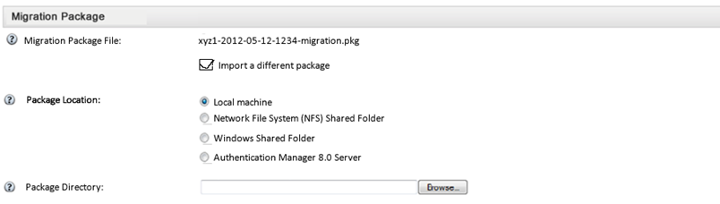

RSAGroupHead | Password

Label | Migration Package Password | Component | RSATextField
Required? | Y | Enabled? | Y
Value | [User entry] | Post Label
Hint | The password used to encrypt the migration package from version 7.1

RSAButtonRow – Bottom only
Button Name / Style | Action | Title
Cancel / button_lt | Discard changes, go to OC home page. | Cancel
Next/ button_rt | Go to the migration confirmation screen | Next

Page Specific Error Handling & Messages
Condition | Page top message | Field(s)
If Migration Package Master Password is wrong. | [Stay on the page with the same error message]
Upload option is chosen and admin didn’t browse to an appropriate file | Specify the location of the migration package.
The nfs or winshare location is incorrect format or doesn’t exist | The specified location is invalid.
No package found error message | The specified location does not contain a migration package file.

Import Migration – Multiple Package Files

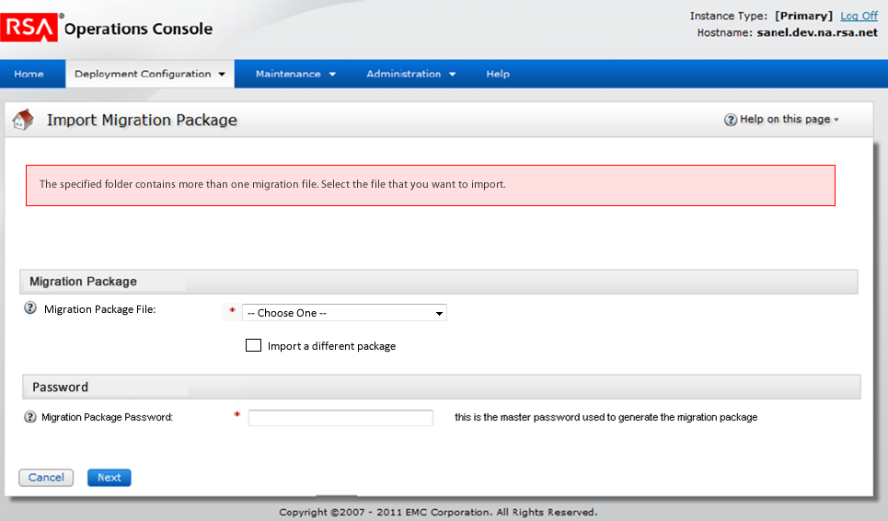

Revision Date | Description | Revised By
05/18/12 | Initial Draft | Dip Roychowdhury

RSAPageHeaderTab

headerImage | Icn_importpkg.gif
headerText | Import Migration Package
introText | NA
Required Field Note? | Y

Error Message: “The specified folder contains more than one migration file. Select the file you want to import”

Form Area

RSAGroupHead | Migration Package

Label | Migration Package File | Component | RSA Select Options
Required? | Y | Enabled? | Y
Default Value | -- Choose One --
Values | [list of package file names of the .pkg files found in the location specified on the previous screen]
Hint | Select from the list of files with a .pkg extension found in the location you specified earlier.

Label | NA | Component | RSA CheckBox
Required? | N | Enabled? | Y
PostLabel | Import a different package
Default | unchecked
Hide/Show | When checked show the package location options. Refer the spec of the previous screen for details on that

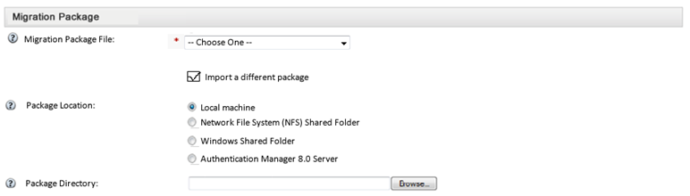

RSAGroupHead | Password

Label | Migration Package Password | Component | RSATextField
Required? | Y | Enabled? | Y
Value | [User entry] | Post Label
Hint | The password used to encrypt the migration package from version 7.1

RSAButtonRow – Bottom only
Button Name / Style | Action | Title
Cancel / button_lt | Discard changes, go to OC home page. | Cancel
Next/ button_rt | Go to the migration confirmation screen | Next

Page Specific Error Handling & Messages
Condition | Page top message | Field(s)
If Migration Package Master Password is wrong. | [Show the page for master password error]
Upload option is chosen and admin didn’t browse to an appropriate file | Specify the location of the migration package.
The nfs or winshare location is incorrect format or doesn’t exist | The specified location is invalid.
No package found error message | The specified location does not contain a migration package file.
If they don’t select a pkg file | Select a migration package file to import

Primary re-import refresh option

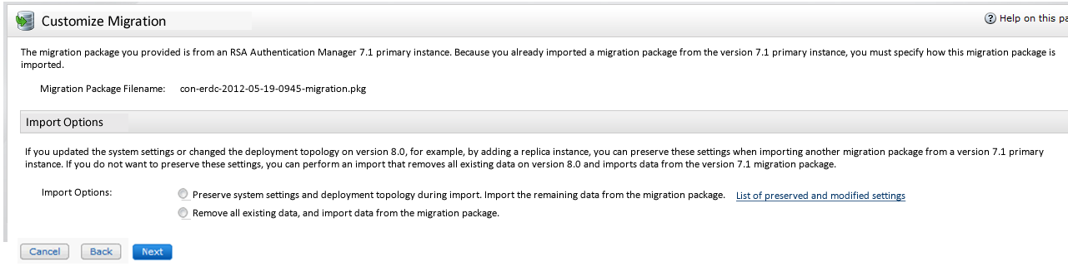

Revision Date | Description | Revised By
09/03/12 | Initial Draft | Dip Roychowdhury

RSAPageHeaderTab

headerImage | Icn_importpkg.gif
headerText | Customize Migration
introText | The migration package you provided is from an RSA Authentication Manager 7.1 primary instance. Because you already imported a migration package from the version 7.1 primary instance, you must specify how the migration package is imported.
Required Field Note? | Y

Form Area

Label | Migration Package Filename | Component | RSATextField
Required? | NA | Enabled? | NA
Value | [the file name of the migration pkg they uploaded earlier] | Readonly | Y
Hint | NA

RSAGroupHead | Import Options

Label |  | Component | RSASimpleText
Required? | NA | Enabled? | NA
Value | During this import, you can retain system settings and the deployment topology, or completely overwrite the database with data from the migration package. | Readonly | Y
Hint | NA

Label | NA | Component | Javascript Tooltip
Required? | NA | Enabled? | NA
Link Text | List of retained settings.
Tooltip contents | Replica instances, Web tiers and a subset of the following are retained:\  • System settings  • Self-Service settings  • Network settings  • Certificates  • Backup & restore settings  • Log settings  • Virtual host settings  • Agent contact list  • RADIUS server configuration  • Software token profiles  • Risk-Based Authentication polices  For a detailed list of retained data, see the RSA Authentication Manager 7.1 to 8.0 Migration Guide.
Hide/Show | Show next to the text above

Label | Import Options | Component | RSA Multi Radios
Required? | Y | Enabled? | NA
Options | - Retain system settings and the deployment topology. Import the remaining data from the migration package.  - Remove all existing data, and import data from the migration package.
Default | None
Hint | NA

RSAButtonRow – Bottom only
Button Name / Style | Action | Title
Cancel | Discard changes, go to OC home page. | Cancel
Back | Go to the upload package page | Back
Next (in focus) | Go to the migration confirmation screen | Next

Page Specific Error Handling & Messages
Condition | Page top message | Field(s)
If they hit next without selecting an option | You must select a migration option

Migration Package Confirmation

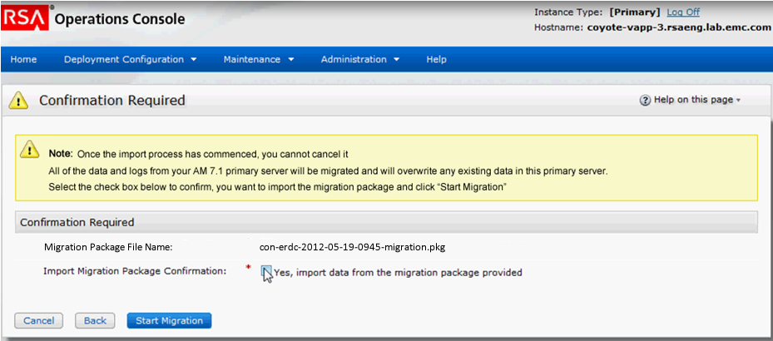

Revision Date | Description | Revised By
03/21/12 | Initial Draft | Dip Roychowdhury
05/17/12 | Added migration pkg file name | Dip Roychowdhury
09/05/12 | Added a messages for the case where primary is imported again | Dip Roychowdhury

RSAPageHeaderTab
headerImage | icn_warning.gif
headerText | Confirmation Required
showHelp | true
pageHelpID
introText | n/a

RSAButtonRow



Button Name / Style | Action | Title
Cancel / button_x | Go to Home | Cancel
Back/ button_lt | Goto the import migration package page | Back
Start Migration/button_gt | Goto progress display | Start Migration

Form Area
Note: Display the warning as shown in the screenshot, on page load

Text | The import process removes existing data from this primary instance and import all data and logs from the RSA Authentication Manager 7.1 primary instance.  After the import begins, you cannot click Cancel.  Select the check box to confirm that you want to import the migration package, and click Start Migration. | Component | Warning box (if primary is being migrated also if the primary is getting migrated again and they chose to overwrite all existing data)
Text | Once the import process begins, you cannot click Cancel.  Data from your Authentication Manager 7.1 replica instance will be migrated and merged into this primary instance.  Select the check box to confirm that you want to import the migration package, and click Start Migration. | Component | Warning box (if replica is being migrated)
Text | The import process will retain the system settings and topology of this deployment and import the remaining data from the migration package.  After the import begins, you cannot click Cancel.  Select the checkbox to confirm that you want to import the migration package, and click Start Migration. | Component | Warning box (if primary is being migrated again and they chose to reatin the system settings)

RSAGroupHead | Confirmation Required

Label | Migration Package File Name | Component | RSA Text Box
Required? | N | Enabled? | Y, appears for all kinds of upload options, NFS, winshare, etc
Readonly | Y | Value | [filename of the pkg they uploaded]

Label | Import Migration Package Confirmation | Component | RSA Checkbox
Required? | Y | Enabled? | Y
Post label | Yes, import data from the provided migration package.

Page Specific Error Handling & Messages
Condition | Page top message

Confirmation Messages
Condition | Message

Help on this page
Help topics | Link

Import Progress (for primary migration)

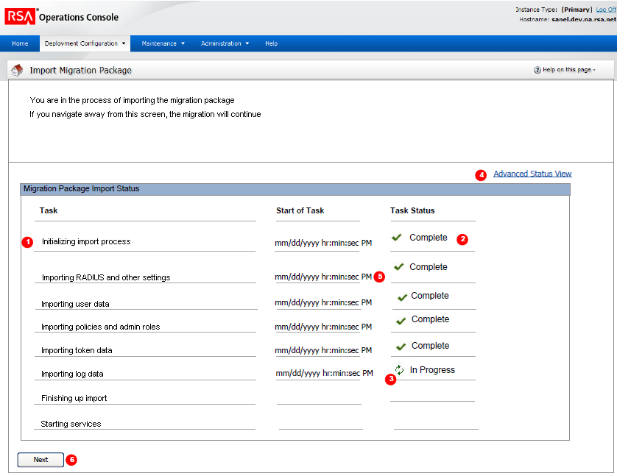

Revision Date | Description | Revised By
11/11/11 | Added the progress display | Dip Roychowdhury

- The data content displayed in the screenshot is only a sample of what the progress monitor will display;
- At the end of a process the progress monitor throws an error or a confirmation message within the “Basic Progress Monitor or Advanced Status View” –area in the UI.
Title
Browser Title | Progress Monitor
RSAPageHeaderTab
headerImage | icn_progress_monitor.gif
headerText | Progress Monitor
buttonURL
buttonText
Default introText | If there are no tasks in progress or that have recently completed;  There are no tasks currently running.
introText | Authentication Manager is importing a migration package.  If you navigate away from this screen, migration continues.  For detailed information about the import process, click Advanced Status View.
Link | “Advanced Status View” display the link below the intro text at the right as shown in the screenshot

Form Area – Basic Progress Monitor

RSAGroupHead | Current Status

Label | Task | Component | N/A
Label | Start of Task | Component | [Date/Time]
Label | Task Status | Component | [Check mark icon] “Completed Successfully”  Or  [warning icon] “Completed with Errors”  Or  [Error icon] “Unsuccessful”
Required? | N | Enabled? | Y
Value | [Dynamic Status] refresh every 3 secs  Display nothing for first 3 secs page load; after display either “No task status available” or start dynamic status display | Format | <Standard> lighter grey font color
List of Tasks for importing migration pkg from the primary | • Initializing import process  • Preparing the database [only appears if they chose to retain settings during 2nd or later migration]  - Importing system configuration data [doesn’t appear if they chose to retain settings during 2nd or  later migration]  • Importing user data  • Importing policy data  • Importing administrative roles and permission data  • Importing trusted realm data  • Importing token data  - Importing password dictionary file [doesn’t appear if they chose to retain settings during 2nd or  later migration]  • Importing self-service data  • Importing log data (if included in the package)  - Importing certificates [doesn’t appear if they chose to retain settings during 2nd or  later migration]  • Importing RADIUS data  • Starting services
 | Show only if a task is either in progress or has completed but the Next button was not selected. Once the Next button is selected, the tasks will be cleared.

Form Area - Advanced Status View
RSAGroupHead | Dynamic Status Display

Label | Task Status | Component | N/A
Required? | N | Enabled? | Y
Value | Preparing for migration  Initiating setup process  Performing setup process  Unpacking migration package  Importing system properties  Stopping services  Importing version 7.1 primary instance data  Importing from DB table: IMS_KEY_STORE  Status: COMPLETED, Records processed: 19, Errors: 0  .  .  .  .  .  Finalizing version 7.1 primary instance data import  Checking network settings  Importing version 7.1 RADIUS server database  Importing version 7.1 RADIUS clients  Finalizing version 7.1 RADIUS import  Starting services  Completing migration process  [in case of success] The migration completed successfully  [in case of error] The migration completed with X errors
Special case | If they choose to retain settings during 2nd or later migration. Only a subset of the tables above are imported, since the ones involving settings are not imported. So only the imported ones will be shown here.
 | Show only if a task is either in progress or has completed but the Next button was not selected. Once the Next button is selected, the tasks will be cleared.
Button Row (top/bottom)
Button Name/Style | Action | Title
Next / button_x | It takes user to the Import results page | Next
 | The Next button will only appear after all tasks are completed. Until then the Next button will be hidden.

Confirmation Messages
Condition | Message

Page Specific Error Handling & Messages
Condition |  | Task-Status Content

Import Progress with exceptions (for primary migration)

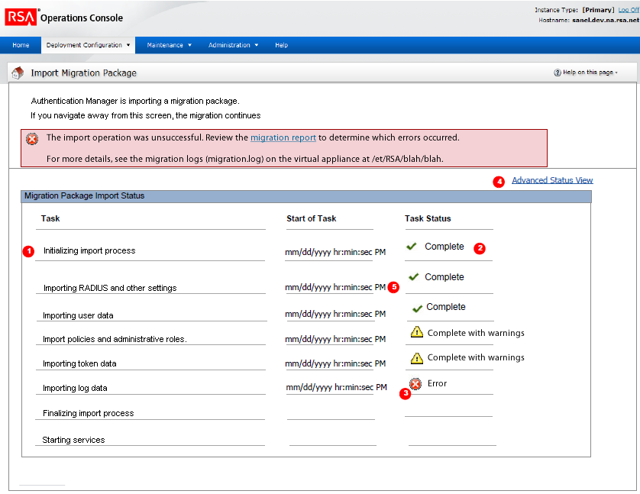

Revision Date | Description | Revised By
11/11/11 | Added the progress display | Dip Roychowdhury

- For details on the specifics of the progress display, please scroll up to 1.4 Import Progress. Below we talk about how the progress display handles exceptions
Title
Browser Title | Progress Monitor
RSAPageHeaderTab
headerImage | icn_progress_monitor.gif
headerText | Progress Monitor
buttonURL
buttonText
Default introText | If there are no tasks in progress or that have recently completed;  There are no tasks currently running.
introText | Authentication Manager is importing a migration package.  If you navigate away from this screen, migration continues.  For detailed information about the import process, click Advanced Status View.
Link | “Advanced Status View” display the link below the intro text at the right as shown in the screenshot

Error Message
Box type | Error
Icon | Icn_erro.gif
Condition | If there is a fatal error during migration causing it to stop
Message | “The import operation was unsuccessful. Click “Download Migration Report” to review the migration report and determine which errors occurred.”  Note: The services on this instance are stopped.”
If the error happens too soon, so the report is not generated yet, show the following message:

“The import operation was unsuccessful. See the Advanced Status View to determine which errors occurred”
If they uploaded replica pkg before importing primary | “You must import the migration package from the version 7.1 primary instance before importing a migration package from a version 7.1 replica instance. The migration package from the primary instance must be generated with the Advanced Migration export option.”
Link | “Advanced Status View” display the link below the intro text at the right as shown in the screenshot

Form Area – Basic Progress Monitor
RSAGroupHead | Current Status

Label | Task | Component | N/A
Label | Start of Task | Component | [Date/Time]
Label | Task Status | Component | If there is an error count for a category, meaning some objects of that category were dropped not resulting in a fatal error, show a warning icon with text “Completed with Warnings”  If there is a fatal error while migrating a certain category, show an error icon with text “Error” and an error box at the top with error message
Required? | N | Enabled? | Y
Value | [Dynamic Status] refresh every 3 secs  Display nothing for first 3 secs page load; after display either “No task status available” or start dynamic status display | Format | <Standard> lighter grey font color
List of Tasks for importing migration pkg from the primary | • Initializing import process  • Importing system configuration data  • Importing user data  - Password Policies  - Lockout Policies  - Self-Service Troubleshooting Policies  - Token Policies  - Offline Authentication Policies  • Importing administrative roles and permission data  • Importing trusted realm data  • Importing token data  • Importing password dictionary file  • Importing self-service data  • Importing log data  • Importing certificates  • Importing RADIUS data  • Starting services
 | Show only if a task is either in progress or has completed but the Next button was not selected. Once the Next button is selected, the tasks will be cleared.

Button Row (top/bottom)
Button Name/Style | Action | Title
Done / button_x | Takes to Home page. At this point, migration has failed so there is no next page to go to. | Done
Download Migration Report / button_gt | Opens up a dialog box to open/save/cancel migration report | Download Migration Report

Import Progress (for replica migration)

Revision Date | Description | Revised By
04/17/12 | Added the progress display | Dip Roychowdhury

Title
Browser Title | Progress Monitor
RSAPageHeaderTab
headerImage | icn_progress_monitor.gif
headerText | Progress Monitor
buttonURL
buttonText
Default introText | If there are no tasks in progress or that have recently completed;  There are no tasks currently running.
introText | Authentication Manager is importing a migration package.  If you navigate away from this screen, migration continues.  For detailed information about the import process, click Advanced Status View.
Link | “Advanced Status View” display the link below the intro text at the right as shown in the screenshot

Form Area – Basic Progress Monitor

RSAGroupHead | Current Status

Label | Task | Component | N/A
Label | Start of Task | Component | [Date/Time]
Label | Task Status | Component | [Check mark icon] “Completed Successfully”  Or  [warning icon] “Completed with Errors”  Or  [Error icon] “Unsuccessful”
Required? | N | Enabled? | Y
Value | Preparing to import replica migration package  Importing updates to authentication agent data  Importing updates to authenticator data  Importing updates to user data  Importing updates to log data  Performing cleanup tasks
 | Show only if a task is either in progress or has completed but the Next button was not selected. Once the Next button is selected, the tasks will be cleared.

Form Area - Advanced Status View
RSAGroupHead | Dynamic Status Display

Label | Task Status | Component | N/A
Required? | N | Enabled? | Y
Value | List the tables imported in the following format:  Importing updates from database table: [table name]  Status: [completed or processing], Records Processed: [number], Records Discarded: [number], Errors: [number]
 | Show only if a task is either in progress or has completed but the Next button was not selected. Once the Next button is selected, the tasks will be cleared.
Button Row (top/bottom)
Button Name/Style | Action | Title
Next / button_x | It takes user to the Import results page | Next
 | The Next button will only appear after all tasks are completed. Until then the Next button will be hidden.

Confirmation Messages
Condition | Message

Page Specific Error Handling & Messages
Condition |  | Task-Status Content

Import Results – Happy path (for primary migration)

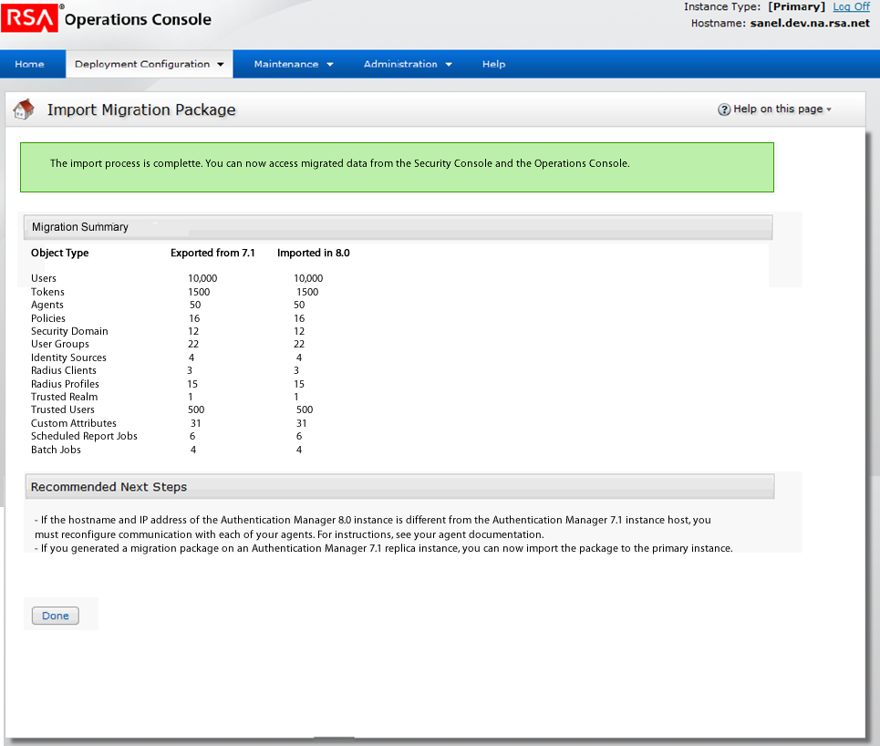

Revision Date | Description | Revised By
03/19/12 | Initial Draft | Dip Roychowdhury
04/03/12 | Updated to include the migration summary | Dip Roychowdhury
05/23/12 | Added log count to the summary | Dip Roychowdhury

RSAPageHeaderTab
headerImage | Icn_importpkg.gif
headerText | Import Migration Package
showHelp
pageHelpID
introText | n/a

RSAButtonRow



Button Name / Style | Action | Title
Done / button_x | Go to Home | Done

Form Area
Note: Display the confirmation as shown in the screen, on page load

Confirmation msg: “The import process is complete. You can now access migrated data from the Security Console and the Operations Console.”

RSAGroupHead | Migration Summary

Label | NA | Component | Text
Value | Type of Data Exported from 7.1 Imported in 8.0  Users With Authenticators [Number of users exported] [Number of users imported]  Assigned Tokens  Available Tokens  Agents  Password Policies [show objects exported and imported as described for users above]  Lockout Policies  Self-Service Troubleshooting Policies  Token Policies  Oflline Authentication Policies  Security Domain  User Groups  Identity Sources  Radius Clients  Radius Profiles  Trusted Realm  Trusted Users  Custom Attributes  Batch Jobs  Administrative Audit Logs  System Logs  Runtime Audit Logs
 | Show only if a task is either in progress or has completed but the Next button was not selected. Once the Next button is selected, the tasks will be cleared.

Label | NA | Component | RSA Text
Required? | N | Readonly | Y
Text | Note: The version 7.1 Super Admin and Operations Console administrator accounts replace the Super Admin and Operations Console administrator accounts that are created during version 8.0 Quick Setup. | Enabled?

RSAGroupHead | Recommended Next Steps

Label |  | Component | RSA Text
Required? | N | Readonly | Y
Text if migration pkg from 7.1 primary instance | - If the hostname and IP address of this instance is different than the RSA Authentication Manager 7.1 primary instance, you must generate new configuration files for the authentication agents and distribute them to the agents.  - If you generated migration packages from the replica instances, you can import each migration package to this instance. | Enabled?
Text if migration pkg from 7.1 replica instance | - Migrate data from the remaining Authentication Manager 7.1 instances. To do this, you must generate migration package on each replica instance, and import the migration package into this instance. | Enabled?

Page Specific Error Handling & Messages
Condition | Page top message

Confirmation Messages
Condition | Message

Help on this page
Help topics | Link

Import Results – With Warnings (for primary migration)

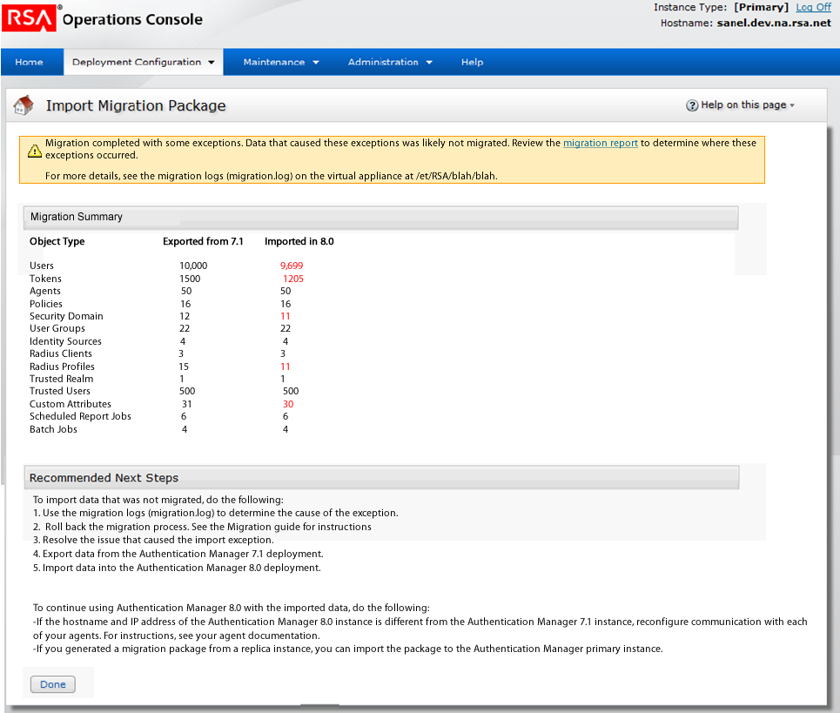

Revision Date | Description | Revised By
03/19/12 | Initial Draft | Dip Roychowdhury
04/03/12 | Updated to include the migration summary | Dip Roychowdhury
05/23/12 | Added log count | Dip Roychowdhury
01/22/13 | Corrected the name of the log in the next steps | Dip Roychowdhury

RSAPageHeaderTab
headerImage | Icn_importpkg.gif
headerText | Import Migration Package
showHelp
pageHelpID
introText | n/a

RSAButtonRow

Button Name / Style | Action | Title
Done / button_x | Go to Home | Done
Download Migration Report/ button_gt | Opens up a dialog box to open/save/cancel migration report | Download Migration Report

Form Area
Note: Display the warning message as shown in the screen, on page load

Warning msg: “Migration completed with some errors. Data that caused these errors was likely not migrated Click “Download Migration Report” to review the migration report and determine which errors occurred.”

RSAGroupHead | Migration Summary

Label | NA | Component | Text (if the counts do not match, display the imported count in red font)
Value | Type of Data Exported from 7.1 Imported in 8.0  Users With Authenticators [Number of users exported] [Number of users imported]  Assigned Tokens  Available Tokens  Agents  Password Policies [show objects exported and imported as described for users above]  Lockout Policies  Self-Service Troubleshooting Policies  Token Policies  Oflline Authentication Policies  Security Domain  User Groups  Identity Sources  Radius Clients  Radius Profiles  Trusted Realm  Trusted Users  Custom Attributes  Batch Jobs  Administrative Audit Logs  System Logs  Runtime Audit Logs
 | Show only if a task is either in progress or has completed but the Next button was not selected. Once the Next button is selected, the tasks will be cleared.

Label | NA | Component | RSA Text
Required? | N | Readonly | Y
Text | Note: The version 7.1 Operations Console administrator accounts are not migrated. The version 7.1 Super Admin accounts replace the Super Admin account that is created during version 8.0 Quick Setup. | Enabled?

RSAGroupHead | Recommended Next Steps

Label |  | Component | RSA Text
Required? | N | Readonly | Y
Text if migration pkg from 7.1 primary instance | To import data that was not migrated, do the following:  - Use the migration logs (migrationReport.log) to determine the cause of the exception.  - Roll back the migration process. See the Migration guide for instructions  - Resolve the issue that caused the import exception.  - Export data from the Authentication Manager 7.1 deployment.  - Import data into the Authentication Manager 8.0 deployment.  To continue using Authentication Manager 8.0 with the imported data, do the following:  - If the hostname and IP address of the Authentication Manager 8.0 instance is different from the Authentication Manager 7.1 instance, reconfigure communication with each of your agents. For instructions, see your agent documentation.  - If you generated a migration package from a replica instance, you can import the package to the Authentication Manager primary instance. | Enabled?
Text if migration pkg from 7.1 replica instance | TBD | Enabled?

Page Specific Error Handling & Messages
Condition | Page top message

Confirmation Messages
Condition | Message

Help on this page
Help topics | Link

Import Results – Happy path (for replica migration)

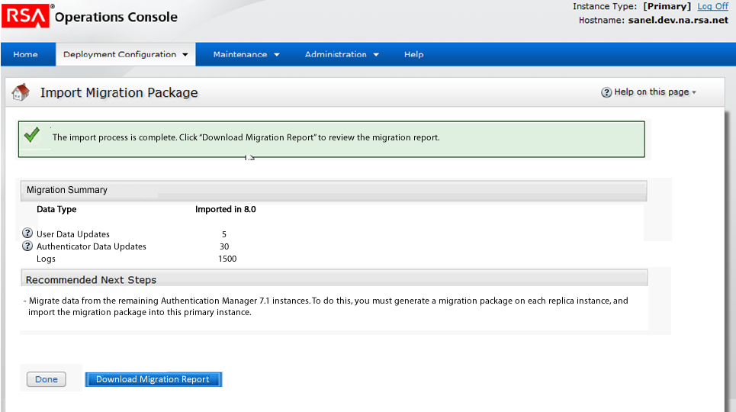

Revision Date | Description | Revised By
06/18/12 | Initial Draft | Dip Roychowdhury

RSAPageHeaderTab
headerImage | Icn_importpkg.gif
headerText | Import Migration Package
showHelp
pageHelpID
introText | n/a

RSAButtonRow

Button Name / Style | Action | Title
Done / button_x | Go to Home | Done
Download Migration Report | Opens up a browser dialog box to open or save the report | Download Migration Report

Form Area
Note: Display the confirmation as shown in the screen, on page load

Confirmation msg: “The import process is complete. Click “Download Migration Report” to review the migration report.”

RSAGroupHead | Migration Summary

Label | NA | Component | Text
Value | Type of Data Updates Imported in 8.0  [iHelp] User Data Updates [Number of user related updates imported]  [iHelp] Authenticator Data Updates  [iHelp] Agent Data Updates  [iHelp] Runtime Audit Logs
[iHelp] User Data Updates | Updates resulting from authentication that are made to user profiles. For example, a user’s last login date.
[iHelp] Authenticator Data Updates | Updates resulting from authentication that are made to a user’s authenticator. For example, a token PIN change.
[iHelp] Agent Data Updates | Updates made to the authentication agent record by the auto-registration service. For example, a change made to an agent IP address.
[iHelp] Authentication Logs | Logs for authentication updates, including PIN and password changes, that occurred on the replica instance while the primary instance was unavailable.

RSAGroupHead | Recommended Next Steps

Label |  | Component | RSA Text
Required? | N | Readonly | Y
Text if migration pkg from 7.1 replica instance | - Migrate data from the remaining Authentication Manager 7.1 instances. To do this, you must generate migration package on each replica instance, and import the migration package into this instance. | Enabled?

Page Specific Error Handling & Messages
Condition | Page top message

Confirmation Messages
Condition | Message

Help on this page
Help topics | Link

Import Results – completed with errors (for replica migration)

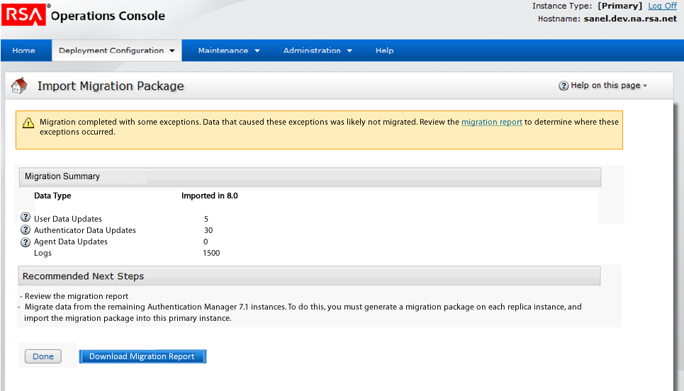

Revision Date | Description | Revised By
06/18/12 | Initial Draft | Dip Roychowdhury

RSAPageHeaderTab
headerImage | Icn_importpkg.gif
headerText | Import Migration Package
showHelp
pageHelpID
introText | n/a

RSAButtonRow

Button Name / Style | Action | Title
Done / button_x | Go to Home | Done
Download Migration Report | Opens up a browser dialog box to open or save the report | Download Migration Report

Form Area
Note: Display the warning as shown in the screenshot, on page load

Confirmation msg: “Migration completed with some errors. Data that caused these errors was likely not migrated. Click Download Migration Report to review the migration report and determine which errors occurred.”

RSAGroupHead | Migration Summary

Label | NA | Component | Text
Value | Type of Data Updates Imported in 8.0  [iHelp] User Data Updates [Number of user related updates imported]  [iHelp] Authenticator Data Updates  [iHelp] Agent Data Updates  [iHelp] Runtime Audit Logs
[iHelp] User Data Updates | Updates resulting from authentication that are made to user profiles. For example, a user’s last login date.
[iHelp] Authenticator Data Updates | Updates resulting from authentication that are made to a user’s authenticator. For example, a token PIN change.
[iHelp] Agent Data Updates | Updates made to the authentication agent record by the auto-registration service. For example, a change made to an agent IP address.
[iHelp] Authentication Logs | Logs for authentication updates, including PIN and password changes, that occurred on the replica instance while the primary instance was unavailable.

RSAGroupHead | Recommended Next Steps

Label |  | Component | RSA Text
Required? | N | Readonly | Y
Text if migration pkg from 7.1 replica instance | - Review the migration. Click Download Migration Report.  - Migrate data from the remaining Authentication Manager 7.1 instances. To do this, you must generate migration package on each replica instance, and import the migration package into this instance. | Enabled?

Page Specific Error Handling & Messages
Condition | Page top message

Confirmation Messages
Condition | Message

Help on this page
Help topics | Link

Sample Migration Report – Primary Import

Migration Report - Mon, 04/09/2012 16:17 PM

The import of version 7.1 data completed with errors. Review this report for more information.

This report summarizes the migration, including migrated data and tables, status of migrated data, time it took to import data, and the number of errors that occurred.

[If they are doing a 2nd or later migration and chose to retain settings, show this instead of the paragraph above]
The import completed with errors. The system settings and the topology of this deployment were retained.
For a list of retained data, see the RSA Authentication Manager 7.1 to 8.0 Migration Guide.

The stack trace for migration errors are in the Authentication Manager log files. To access these logs, in the Operations Console, go to Administration> Download Troubleshooting Files, and select Authentication Manager Log Files. The stack trace for database tables that were migrated with errors is in <table_name>.log. The stack trace for other migration tasks is in MigrationTaskError.log.

Migration Summary:

Note:
The following numbers of migrated data may vary slightly from the total numbers you see in the Security Console or Operations Console. This results from some of the default settings in version 8.0. For example, in version 8.0, two system users are automatically configured during Quick Setup and are listed among the internal database users in the Security Console. When you view a list of users in the Security Console, the total number includes two more users than the number you see in this report. For a list of migrated data that may report different numbers than what you see in a console, see the RSA Authentication Manager 7.1 to 8.0 Migration Guide.

- Some date might not have been migrated because it is not longer supported in version 8.0. For a detailed list of data that is not migrated, see the RSA Authentication Manager 7.1 to 8.0 Migration Guide.
- The version 7.1 Super Admin and Operations Console administrator accounts replace the Super Admin and Operations Console administrator accounts that are created during version 8.0 Quick Setup.

- For better text alignment in a rich text editor, use fonts with a fixed length such as Courier, Franklin Gothic, and Consolas.

Type of Data Exported from 7.1 Imported in 8.0
=============================================================
Users With Authenticators 84 84
Assigned Tokens 54 54
Available Tokens 432 432
Agents 14 14
Security Domains 8 8
User Groups 8 7 **
Identity Sources 4 4
RADIUS Clients 11 11
RADIUS Profiles 10 10
Trusted Realms 3 3
Trusted Users 8 8
Identity Attribute Definitions 44 44
Batch Jobs -1 -1
Lockout Policies 5 5
Password Policies 5 5
Offline Authentication Policies 5 5
Token Policies 5 5
Administrative Audit Logs 12
System Logs
Runtime Audit Logs
=============================================================

** Indicates a difference between the number of records that were exported from version 7.1 and imported into version 8.0.

Database Migration Details:

Database Table Imported Records # Total Errors # Status Process Time
==============================================================================
IMS_LOG_DELETED_SD 0 0 COMPLETED
AM_REALM_SETTINGS 9 0 COMPLETED
IMS_KEY_STORE 19 0 COMPLETED
IMS_LOG_DELETED_IS 0 0 COMPLETED
AM_REMOTE_GROUPS 8 0 COMPLETED
UCM_WORKFLOW_REQUESTS 69 0 COMPLETED
IMS_AUTHN_PWD_DICTIONARY 6 0 COMPLETED
IMS_PRINCIPAL_DATA 84 0 COMPLETED
AM_AGENT_ALTERNATE 0 0 COMPLETED
IMS_SEC_DOMAIN_EA_POLICY 2 0 COMPLETED
IMS_AUTHN_QUES_POLICY 4 0 COMPLETED
IMS_SEC_DOMAIN_AUTHN_POLICY 2 0 COMPLETED
AM_REMOTE_GROUP_PRINCIPALS 4 0 COMPLETED
AM_REMOTE_PRINCIPAL_DATA 8 0 COMPLETED
UCM_REQUEST_ATTRIBUTES 1156 0 COMPLETED
AM_EAP32_PEPPERS 0 0 COMPLETED
IMS_ADMIN_ROLE_SD 36 0 COMPLETED
IMS_PRINCIPAL 64 0 COMPLETED
AM_TOKEN_POLICY_PIN_HISTORY 31 0 COMPLETED
UCM_WORKFLOW_REQUEST_ACTIONS 56 0 COMPLETED
AM_SMS_AUTHENTICATORS 14 0 COMPLETED
IMS_LOG_AUDIT_RT 0 0 COMPLETED
AM_ATTR_DEFINITIONS 60 0 COMPLETED
AM_AGENT_RADIUS_CLIENTS 7 0 COMPLETED
IMS_AUTHN_EA_POLICY 5 0 COMPLETED
IMS_LOG_AUDIT_ADM_CLU 0 0 COMPLETED
IMS_AUTHN_POLICY 11 0 COMPLETED
AM_REMOTE_PRINCIPAL_ATT_VALUES 1 0 COMPLETED
AM_GROUP 3 0 COMPLETED
AM_RADIUS_POLICY_SETTINGS 12 0 COMPLETED
IMS_ADMIN_ROLE_IS 54 0 COMPLETED
IMS_CONFIG_METADATA 84 0 COMPLETED
UCM_GROUPS 4 0 COMPLETED
IMS_GROUP_EXT_ATT_VALUE 0 0 COMPLETED
AM_TOKEN_OOB 432 0 COMPLETED
IMS_AUTHN_LOCKOUT_POLICY 5 0 COMPLETED
AM_SEC_DOMAIN_TOKEN_POLICY 2 0 COMPLETED
IMS_AUTHN_DICTIONARY 1 0 COMPLETED
AM_EAP32_SESSIONS_OOB 0 0 COMPLETED
AM_TOKEN_ATTR_VALUES 97 0 COMPLETED
IMS_GROUP 5 0 COMPLETED
IMS_ADMIN_ROLE 36 0 COMPLETED
IMS_ADMIN_PERM_ATTS 0 0 COMPLETED
AM_AGENT_REMOTE_GROUPS 2 0 COMPLETED
UCM_SECURITY_DOMAINS 7 0 COMPLETED
IMS_PRINCIPAL_ADMIN_ROLE 34 0 COMPLETED
IMS_ADMIN_ROLE_ATTS 0 0 COMPLETED
AM_TOKEN_OTT 70 0 COMPLETED
IMS_CONTROL 2 0 COMPLETED
AM_SELF_SERVICE_TOKEN 18 0 COMPLETED
AM_PRINCIPAL_ATTR_VALUES 0 0 COMPLETED
AM_RADIUS_POLICIES 3 0 COMPLETED
AM_TOKEN_POLICY 5 0 COMPLETED
AM_TOKEN_PUK 0 0 COMPLETED
AM_TOKEN_POLICY_PCODE_HISTORY 12 0 COMPLETED
IMS_PRINCIPAL_EXT_ATT_VALUE 44 0 COMPLETED
IMS_IDENTITY_SOURCE 4 0 COMPLETED
IMS_REALM_PREFERENCE 24 0 COMPLETED
IMS_PRINCIPAL_D_EXT_ATT_VALUE 5 0 COMPLETED
IMS_AUTHN_PASSWORD_POLICY 5 0 COMPLETED
AM_TOKEN 432 0 COMPLETED
IMS_SEC_DOMAIN_QUES_POLICY 0 0 COMPLETED
IMS_AUTHN_PWD_HISTORY 21 0 COMPLETED
AM_PRINCIPAL 44 0 COMPLETED
IMS_ATT_LOGICAL 17 0 COMPLETED
IMS_TRUSTS 3 0 COMPLETED
IMS_LOG_AUDIT_ADM 0 0 COMPLETED
IMS_SEC_DOMAIN_HIERARCHY 21 0 COMPLETED
IMS_ADMIN_PERMISSION 1214 0 COMPLETED
UCM_CONFIG_VALUE 26 0 COMPLETED
AM_CTKIP_AUTHCODE 4 0 COMPLETED
AM_HOST 14 0 COMPLETED
IMS_LOG_AUDIT_RT_CLU 0 0 COMPLETED
UCM_WORKFLOW_OPERATION_POLICY 40 0 COMPLETED
UCM_REQUESTS 85 0 COMPLETED
AM_SEC_DOMAIN_OFFLN_AUTHN_POL 3 0 COMPLETED
IMS_GROUP_DATA 8 0 COMPLETED
AM_RADIUS_CLIENTS 11 0 COMPLETED
IMS_ATT_PHYSICAL 50 0 COMPLETED
IMS_TRUST_INSTANCES 5 0 COMPLETED
UCM_ATT_PHYSICAL 27 0 COMPLETED
AM_TOKEN_REPLACEMENT 3 0 COMPLETED
IMS_CATEGORIES 10 0 COMPLETED
IMS_LOG_SYSTEM 0 0 COMPLETED
AM_ATTR_CATEGORIES 28 0 COMPLETED
IMS_PRINCIPAL_LOGIN_DATE 85 0 COMPLETED
IMS_TRUST_DOMAINS 1 0 COMPLETED
IMS_PRINCIPAL_PREFERENCE 8 0 COMPLETED
IMS_PRINCIPAL_GROUP 32 0 COMPLETED
IMS_AUTHN_METHOD 1 0 COMPLETED
UCM_EMAIL_TEMPLATES 9 0 COMPLETED
IMS_REPORT_QUERY 12 0 COMPLETED
AM_AGENT_GROUP 2 0 COMPLETED
AM_PRINCIPAL_ALIAS 1 0 COMPLETED
AM_OFFLINE_AUTHN_POLICY 5 0 COMPLETED
IMS_GROUP_SUBGROUP 1 0 COMPLETED
IMS_LOG_SYSTEM_CLU 0 0 COMPLETED
IMS_SECDOM_IDSRC_DEPENDENCY 4 0 COMPLETED
IMS_SECURITY_DOMAIN 8 0 COMPLETED
AM_RADIUS_PROFILES 10 0 COMPLETED
IMS_SEC_DOMAIN_PWD_POLICY 3 0 COMPLETED
UCM_IDENTITY_SOURCES 2 0 COMPLETED
IMS_CONFIG_VALUE 413 0 COMPLETED
IMS_SEC_DOMAIN_LCK_POLICY 4 0 COMPLETED
AM_AGENT 14 0 COMPLETED
IMS_LOG_KEYS 145 0 COMPLETED
AM_SW_TOKEN_DEVICE_TYPES 14 0 COMPLETED
IMS_REPORT_QUERY_PARAM_VALUE 20 0 COMPLETED
==============================================================================

Total import time: [hours]:[minutes]
Total error count:

Error Details: ++++++++++++++++++++++++++++++++++++++++++++++++++++++++++++++++++++++++++++++++++++
Total Error Count: 2
Error: RADIUS import failed for some unexpected reason :failed to search objects of type: com.rsa.authmgr.internal.admin.radius.dal.RadiusServerHBM

Error: Unable to lookup RADIUS servers from the system:DAL_OBJECT_NOT_FOUND

++++++++++++++++++++++++++++++++++++++++++++++++++++++++++++++++++++++++++++++++++++

Sample Migration Report – Replica Import (if successful)

Migration Report - Mon, 04/09/2012 16:17 PM

The import of data from version 7.1 replica instance ([put the replica hostname here]) completed successfully.

This report summarizes the migration, including migrated data updates, discarded records, and the errors that occurred.

The stack trace for migration errors are in the Authentication Manager log files. To access these logs, in the Operations Console, go to Administration> Download Troubleshooting Files, and select Authentication Manager Log Files. The stack trace for database tables that were migrated with errors is in <table_name>.log. The stack trace for other migration tasks is in MigrationTaskError.log.

Definitions
=============================================================

User Data Updates: Updates resulting from authentication that are made to user profiles. For example, a user’s last login date.

Authenticator Data Updates: Updates resulting from authentication that are made to a user’s authenticator. For example, a token PIN change.

Agent Data Updates: Updates made to the authentication agent record by the auto-registration service. For example, a change made to an agent IP address.

Discarded Records: Data that is not merged into the version 8.0 primary instance because the latest record already exists in the database. If the number of imported records is less than the number of exported records, some records were discarded.

=============================================================

Migration Summary:
=============================================================

Type of Data Updates Exported from 7.1 Imported into 8.0 Discarded Records
User Data Updates
Authenticator Data Updates
Agent Data Updates
Runtime Audit Logs

=============================================================

** Indicates an error occurred while merging data updates. More details about the errors are included in the Errors section.

Database Migration Details:
==============================================================================
Database Table Imported # Discarded# Errors # Status Process Time
-------------------------------------------------------------------------------------------------------------------------------

==============================================================================

Discarded Records:
=============================================================

=============================================================

Errors:
=============================================================

=============================================================

2. Migration from version 6.1 – Server Database

2.1 Locate Files

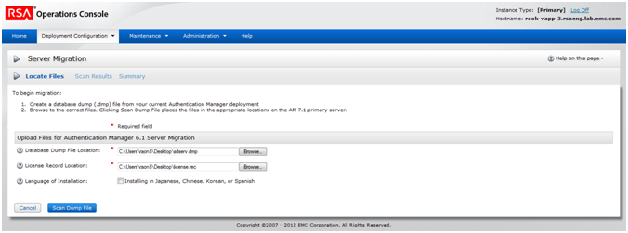
State of Page Design | Draft for Review
URL | http://uxdweb:8080/console-operations/view/configuration/Migration_temp.jsp

Revision Date | Description | Revised By
7/11/07 | Initial Draft | Dipankar Roychowdhury
9/20/07 | Updated intro text | Dipankar Roychowdhury
10/17/07 | Removed the note in the intro text about the limit on dump file size, relying on the limit to get pushed to 2GB otherwise user would have to manually move the files to the 7.1 folder specified in doc. | Dipankar Roychowdhury
11/8/07 | Changed the button text on the button in the bottom row to “Scan Dump File” as per bug 71288 | Dipankar Roychowdhury
11/20/07 | Updated header icon for server migration | Dipankar Roychowdhury
11/29/07 | Edited introText, inserted Help on this Page topic & link, edited Hint text | Bobbie King
12/27/07 | Updated topic name in Help on this page section. | Bobbie King
10/1/12 | Updated page intro text to match GUI | Dan Fitek

RSAConsoleWizard

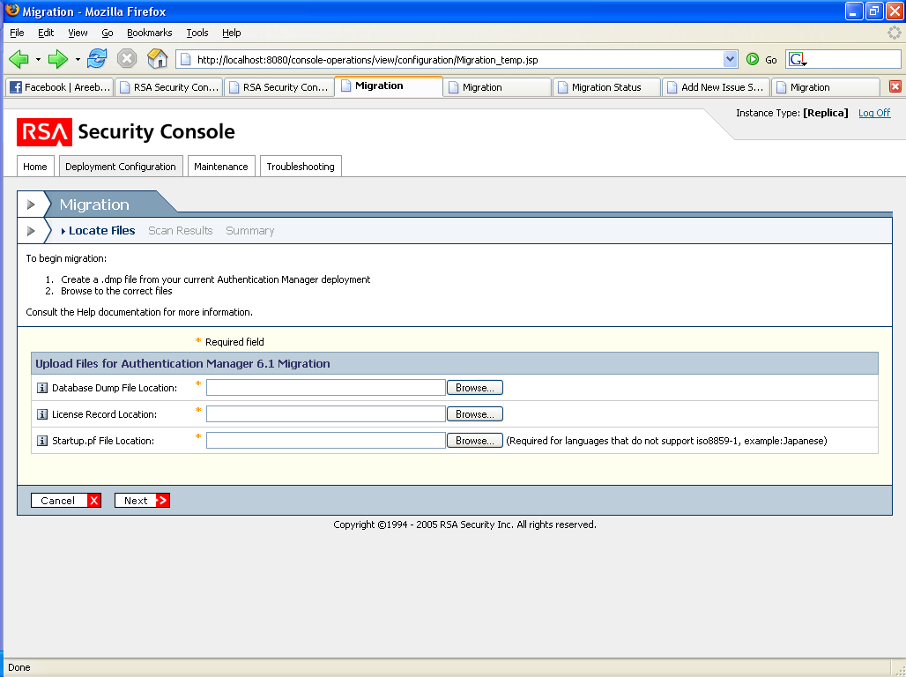

Order | True
Icon | None

RSAConsoleTab | Link | Index
Locate Files | Locate Files | 0
Scan Results | Scan Results | 1
Summary | Summary | 2

RSAPageHeaderTab
headerImage | icn_server_migration.gif
headerText | Server Migration
buttonText | N/A
buttonURL | N/A
stackedMenuList | N/A
backMenuUrl | N/A
backMenuImage | N/A
backMenuText | N/A
stackedMenuListText | N/A
pageHelpID | MigrationHelp
showHelp | Y
introText | To begin migration:  - Create a database dump (.dmp) file from your current Authentication Manager 6.1 deployment.  - Browse to the files. Click Scan Dump File to copy files to this Authentication Manager primary instance. The process of copying files may take a few minutes.
Required Field Note? | Y

Form Area
RSAGroupHead | Upload Files for Authentication Manager 6.1 Server Migration

Label | Database Dump File Location | Component | File Browse
Required? | Y | Enabled? | Y
Value | <User Entry> | Format | <DMP>
Hint | The dump file name is sdserv.dmp and is located in /Data in Authentication Manager 6.1.

Label | License Record Location | Component | File Browse
Required? | Y | Enabled? | Y
Value | <User Entry> | Format | <REC>
Hint | The license file name is License.rec and is located in /Data in Authentication Manager 6.1.

Label | Language of Installation | Component | RSACheckBox
Default State | Unchecked | Enabled? | Y
Prelabel | N/A | Postlabel | Instaling in Japanese, Chinese, Korean or Spanish
Hint | Select if your dump file is in Japanese, Chinese, Korean or Spanish. When selected, you are prompted for the location of the startup.pf file.
Hide/Show | When checked, the field browse component for statup.pf file appears  When unchecked the field browse component is hidden.

Label | Startup.pf File Location | Component | File Browse
Required? | Y | Enabled? | Y
Value | <User Entry> | Format | <LIC>
Post Label | (Required for languages that do not support iso8859-1, example:Japanese)
Hint | The startup.pf file is located in /rdbms32 in Authentication Manager 6.1.

RSAButtonRow

Button Name / Style | Action | Title
Cancel / button_x | Retain the file locations entered, goto Home | Cancel
Scan Dump File / button_gt | Check if the files are already located in the appropriate locations in the server, if yes go to Scan Results page | Scan Dump File

Page Specific Error Handling & Messages
Condition | Page top message | Field-level message | Field(s)
Invalid file type. | An error occurred processing the input files. Please ensure the files are of correct type and are not corrupt | Invalid file type.

Help on this page
Help topics | Link
Data Migration from RSA Authentication Manager 6.1

2.2 Scan Results
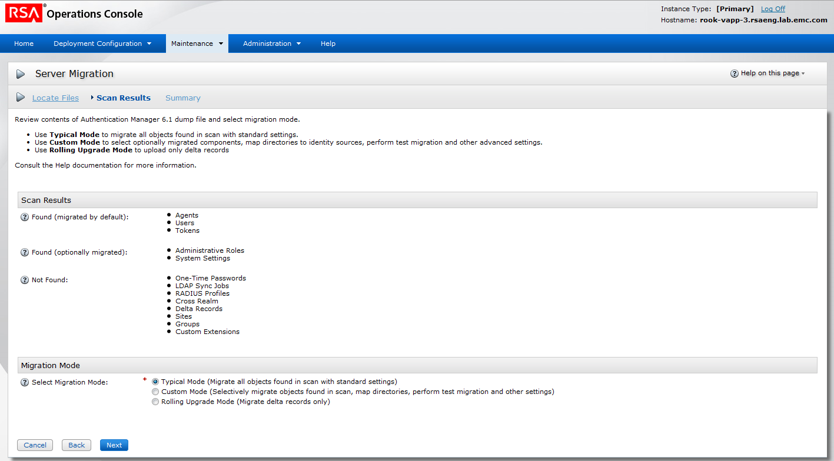

State of Page Design | Draft for Review
URL | http://localhost:8080/console-operations/view/configuration/MigrationScan_temp.jsp

Revision Date | Description | Revised By
3/31/05 | Initial Draft | Dipankar Roychowdhury
11/20/07 | Updated header icon for server migration | Dipankar Roychowdhury
11/29/07 | Edited introText, inserted Help on this Page topic & link, edited Hint text, inserted comment on Hint text | Bobbie King
12/27/07 | Updated topic titles in Help on this page section. | Bobbie King
12/31/07 | Added a warning message for unsupported characters, as per bug 72498 | Dipankar Roychowdhury
23/05/2012 | Added a new section called “Migration Retry Cleanup” on this page | Naznin Rao

RSAConsoleWizard

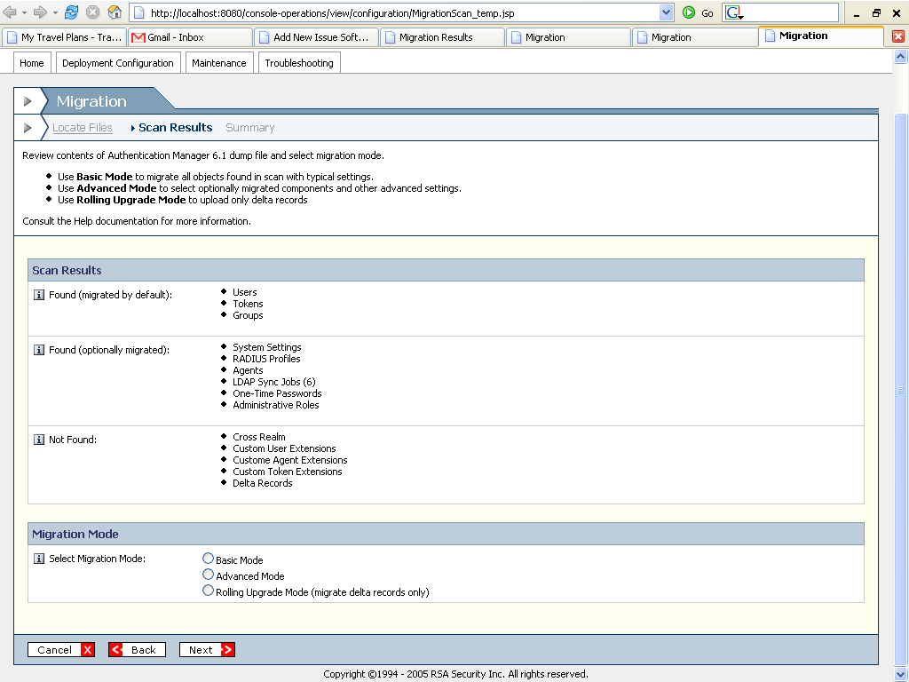

Order | True
Icon | None

RSAConsoleTab | Link | Index
Locate Files | Locate Files | 0
Scan Results | Scan Results | 1
Summary | Summary

RSAPageHeaderTab
headerImage | icn_server_migration.gif
headerText | Server Migration
pageHelpID | MigrationHelp
showHelp | Y
introText
  Review contents of Authentication Manager 6.1 dump file and select migration mode.
  - Use Typical Mode to migrate all objects found in scan with standard settings.
  - Use Custom Mode to select optionally migrated components, map directories to identity sources, perform test migration and other advanced settings.
  - Use Rolling Upgrade Mode to upload only delta records
Required Field Note? | N

Form Area
RSAGroupHead | Scan Results

Label | Found (migrated by default) | Component | RSARow
Value | Provided by backend
Format | Bullets
Hinttext | These components were found in the dump file and will be migrated.

Label | Found (optionally migrated) | Component | RSARow
Value | Provided by backend
Format | Bullets
Hinttext | These components were found in the dump file. You can select those you want to migrate using Custom mode.

Label | Not Found | Component | RSARow
Value | Provided by backend. (displays all components supported by the console whether licensed or not)
Format | Bullets
Hinttext | These components were not found in the dump file.  To migrate these components, create a new dump file that includes them.

RSAGroupHead | Migration Mode

Label | Select Migration Mode | Component | RSAMultiRadios
Required? | N/A | Enabled? | Y
Options | Typical Mode  Custom Mode  Rolling Upgrade Mode (migrate delta records only)
Default | Typical Mode  If LDAP Sync Jobs are found default to Custom mode, If NTLM names are found default to Custom mode  If Delta records are found the only option available is Rolling Upgrade Mode
Hint | - Typical Mode migrates all objects found in the dump file scan with standard settings. The settings will be displayed on the Summary page.  - Custom Mode migrates selected components in addition to those migrated by default.  - Rolling Upgrade Mode migrates delta records only.

RSAGroupHead | Migration Retry Cleanup
IntroText | This option prepares the system for a migration retry. When enabled, only the mapping table from the previous attempt is cleared. You must manually delete the migration data before proceeding. If you are not retrying a failed migration, disable this option.
Hide/Show | Show this section during a migration retry attempt, not during a fresh migration.  Also don’t show this section in scenario where first migration attempt was done in Typical/Custom mode and second attempt done in “Rolling Upgrade Mode”

Label | None | Component | RSACheckBox
Required? | N | Enabled? | Y
Value | Unchecked  checked | Default | checked
Pre-label | N/A
Hint | N/A
Hide/Show | Show when section is enabled
Post Label | Cleanup the system for a migration retry

RSAButtonRow – Bottom only
Button Name / Style | Action | Title
Cancel / button_x | Clear contents, go to Home | Cancel
Back / button_lt | Back to Locate Files | Back
Next / button_gt | Summary (For Typical Mode) - if Typical mode is selected  Customize Migration - If Custom mode selected | Next

Page Specific Error Handling & Messages
Condition | Page top message | Field-level message | Field(s)
Dump file contains unsupported characters  Note: In this case default to Custom mode | (warning message)  “The dump file contains records that contain the unsupported characters < > & % ‘. Select Custom Mode and perform a test migration to identify those records. You must either update those records in the version 6.1 database before migration, or select Replace Unsupported Characters to automatically replace the unsupported characters during migration. See the Authentication Manager 6.1 to 8.0 Migration Guide for additional information.”

Confirmation Messages
Condition | Message
Checkbox under “Migration Retry Cleanup” is checked. On clicking “Next” button, show the confirmation pop-up | Ensure that you have deleted migration data from the previous attempt before continuing.  This action cannot be undone. Proceed?

Help on this page
Help topics | Link
Data Migration from RSA Authentication Manager 6.1

2.3 Customize Migration
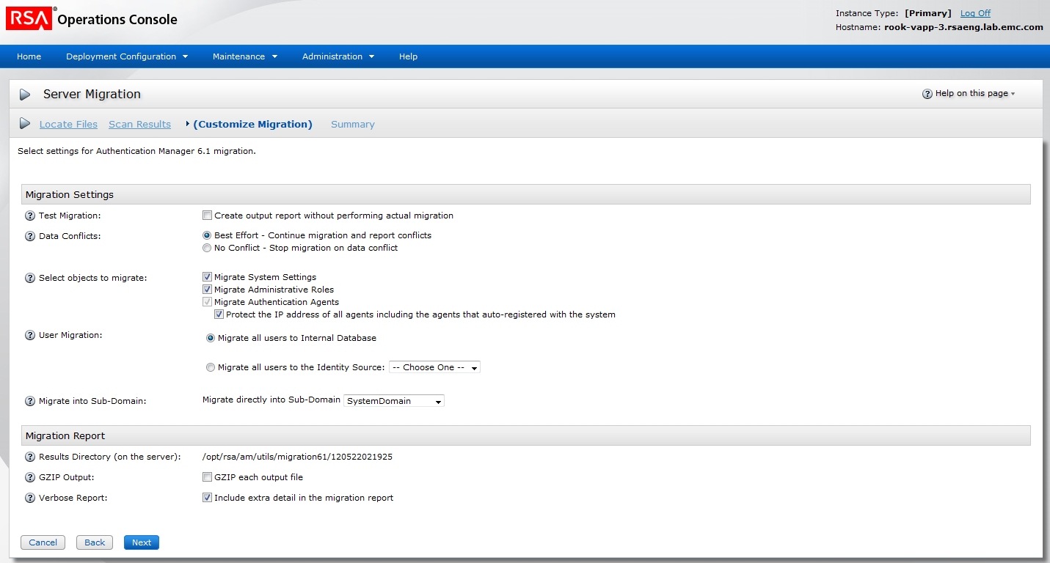

State of Page Design | Draft for Review
URL | http://localhost:8080/console-operations/view/configuration/Migration_temp2.jsp

Revision Date | Description | Revised By
6/11/07 | Initial Draft | Dipankar Roychowdhury
8/10/07 | Changed the default state for GZIP and verbose report form unchecked to checked | Dipankar Roychowdhury
11/20/07 | Updated header icon for server migration | Dipankar Roychowdhury
11/28/07 | Updated the drop down for identity sources and Sub-Domain as per bug 69609 | Dipankar Roychowdhury
11/29/07 | Edited introText, inserted Help on this Page topic & link, edited Hint text | Bobbie King
12/5/07 | Added a checkbox for Protect IP address of auto-registered agents…as per bug 70678 | Dipankar Roychowdhury
12/6/07 | Addded a row on domain name mapping, as per bug 72373 | Dip Roychowdhury
12/27/07 | Updated topic title in Help on this page section and made some minor edits in new Hint text. | Bobbie King
2/7/13 | Added a field for replace unsupported characters | Dip Roychowdhury

RSAConsoleWizard

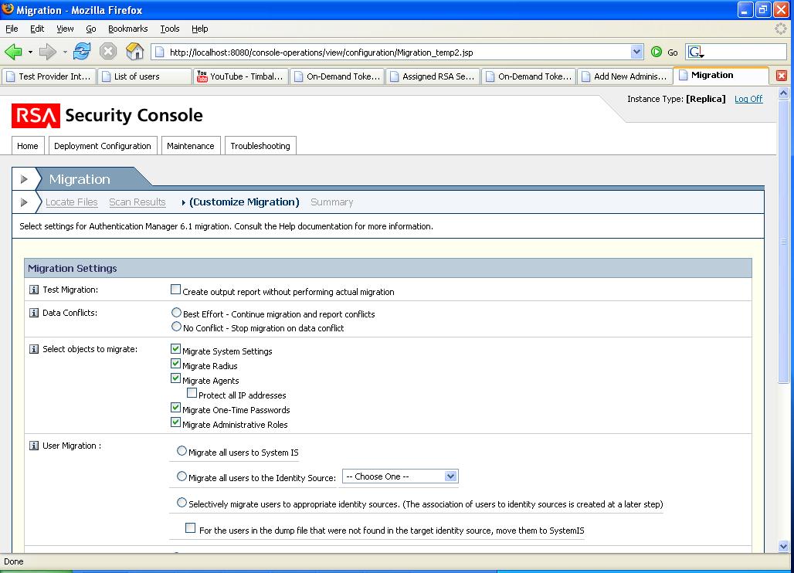

Order | True
Icon | None

RSAConsoleTab | Link | Index
Locate Files | Locate Files | 0
Scan Results | Scan Results | 1
(Customize Migration) | (Customize Migration)
Summary | Summary

RSAPageHeaderTab
headerImage | icn_server_migration.gif
headerText | Server Migration
pageHelpID | MigrationHelp
showHelp | Y
introText | Select settings for Authentication Manager 6.1 migration.
Required Field Note? | N

Form Area
RSAGroupHead | Migration Settings

defer

Label | Test Migration | Component | RSACheckBox
Default State | Un Checked | Enabled? | Y
Prelabel | N/A | Postlabel | Create output report without performing actual migration
Hint | When selected, a test migration is run, which generates a report showing the potential outcome of that migration. The test migration does not affect your actual deployment.

Label | Data Conflicts | Component | RSAMultiRadios
Required? | N/A | Enabled? | Y
Options | Best Effort - Continue migration and report conflicts  No Conflict - Stop migration on data conflict
Default | Best Effort - Continue migration and report conflicts
Hint | In the event of data conflicts, Best Effort continues the migration and describes the data conflicts in the migration report. No Conflict stops the migration and describes the data conflicts in a report.

Label | Select objects to migrate: | Component | RSARow
Hint | The selected components will be migrated. De-select a component if you do not want to migrate it. Certain checkboxes may be hidden if they do not apply.

Label | N/A | Component | RSACheckBox
Default State | Checked | Enabled? | Y
Prelabel | N/A | Postlabel | Migrate System Settings

Label | N/A | Component | RSACheckBox
Default State | Checked | Enabled? | Y
Prelabel | N/A | Postlabel | Migrate Radius

Label | N/A | Component | RSACheckBox
Default State | Checked | Enabled? | Y
Prelabel | N/A | Postlabel | Migrate Administrative Roles

Label | N/A | Component | RSACheckBox
Default State | Checked | Enabled? | N (appears checked and disabled)
Prelabel | N/A | Postlabel | Migrate Authentication Agents
Hide/Show | Display this and the component below ONLY if auto-registered agents were found in the dump.

Label | N/A | Component | RSACheckBox
Default State | Checked | Enabled? | Y
Prelabel | N/A | Postlabel | Protect the IP address of all agents including the agents that auto-registered with the system

Label | User Migration | Component | RSAMultiRadios
Required? | N/A | Enabled? | Y
Options | - Migrate all users to Internal Database  - Migrate all users to the Identity Source: [drop down of all identity sources other than Internal Database]  - Selectively migrate users to appropriate identity sources. (The association of users to identity sources is created at a later step)
Default | - Migrate all users to Internal Database
Hint | Migrates users according to your selection:  1. Migrates all users to the internal database  2. Migrates all users to one identity source other than the internal database. When selected, prompts you to specify whether users that are in the dump file but not in the target identity source should be migrated to the internal database or discarded.  3. Selectively migrates users to the appropriate identity sources by allowing you to map LDAP sync jobs to identity sources in a later step. When selected, prompts you to specify whether users that are in the dump file but not in the target identity source should be migrated to the internal database or discarded.

Label |  |  |  | Component | RSASelectOptions
Multiple? | N | Choose One? | Y | Enabled? | Y
Value | List Only the identity sources that are either unlinked to a realm Or linked to the default realm |  |  | Default | -- Choose One --
Show/Hide

Label |  | Component | RSACheckBox
Default State | Unchecked | Enabled? | Y
Prelabel | N/A | Postlabel | For the users in the dump file that were not found in the target identity source, move them to Internal Database
Hide/Show | When “Migrate all users to the Identity Source:” radio button is selected, this check box appears below that radio option, slightly indented

Label |  | Component | RSACheckBox
Default State | Unchecked | Enabled? | Y
Prelabel | N/A | Postlabel | For the users in the dump file that were not found in the target identity source, move them to Internal Database
Hide/Show | When the radio option for “Selectively migrate users to appropriate identity sources. (The association of users to identity sources is created at a later step):” is selected, this check box appears below that radio option, slightly indented

Label | User ID Format | Component | RSACheckBox
Default State | Checked | Enabled? | Y
Prelabel | N/A | Postlabel | For users being migrated, convert the User ID from NTLM to UPN format using the mapping provided below.
Hide/Show | Display ONLY if NTLM names were found in the dump
Hint | When selected, converts the User ID of migrated users from NTLM to UPN format using the mapping provided.The mapping for NTLM domain names can also be specified after migration in the RSA Security Console.

Label | Domain Name Mapping | Component | RSAAddToList (Only Update button)
Required? | N | Enabled? | Y
Edit Field 1 Label | NTLM Name | Format | <standard>
Edit Field 2 Label | UPN Name | Format | <Standard>
List Format | Edit Field 1 # Edit Field 2
Hinttext | Provide mapping between NT Lan Manager (NTLM) domain names and Windows 2000 Fully Qualified Domain Names (FQDN). This option is also available after migration in the RSA Security Console.
Hide/Show | Display only if NTLM names are found in the dum and the checkbox above is selected.

Label | Migrate into Sub-Domain |  |  | Component | RSASelectOptions
Multiple? | N | Choose One? | N | Enabled? | Y
Prelabel | Migrate directly into sub-domain: |  |  | Default | System Domain
value | List of security domains within the default realm
Hint | Migrates all users into the security domain you select.

Label | Replace Unsupported Characters | Component | RSACheckBox
Default State | UnChecked | Enabled? | Y
Prelabel | N/A | Postlabel | Replace the five characters that are not supported in version 8.0 < > & % ` with + { } / ' respectively
Hint | For security purposes, the HTML-based consoles in version 8.0 do not support certain characters. Use this feature to automatically replace the unsupported characters < > & % ` found in the dump file with + { } / ' . Because this changes the migrated data, RSA recommends that you perform a test migration to identify the specific records containing unsupported characters and manually update them before migration.

Label |  | Component | RSARow
Text | [warning icon] Warning: This changes the migrated data, such as user IDs and user extension data. See the migration report to determine the specific records affected by this change.

RSAGroupHead | Migration Report

Label | Results Directory (on the server) | Component | RSARow
Value | [standard directory location] | Enabled? | Y
Hint | "Specifies the location of the migration results. The directory is on the same machine as primary Authentication Manager server. "

Label | GZIP Output | Component | RSACheckBox
Default State | UnChecked | Enabled? | Y
Prelabel | N/A | Postlabel | GZIP each output file
Hint | When selected, places migration results in a GZIP output file.

Label | Verbose Report | Component | RSACheckBox
Default State | Checked | Enabled? | Y
Prelabel | N/A | Postlabel | Include extra detail in the migration report
Hint | When selected, the migration report contains details for all migrated components.

RSAButtonRow – Bottom only
Button Name / Style | Action | Title
Cancel / button_x | Clear contents, go to Home | Cancel
Back / button_lt | Back to Scan Results | Back
Next / button_gt | Go to Upload Sync Job Files – if the radio option for “Selectively migrate users to appropriate identity sources. (The association of users to identity sources is created at a later step)”  Otherwise Go to Summary (For Custom Mode) | Next

Page Specific Error Handling & Messages
Condition | Page top message | Field-level message | Field(s)
If all NTLM mappings are not entered | “Please provide domain name mapping for all the NTLM domain names listed.”

Confirmation Messages
Condition | Message

Help on this page
Help topics | Link
Perform a Customized Migration

2.4 Upload Sync Job Files

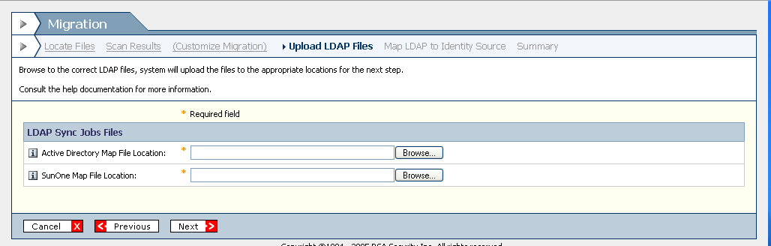

State of Page Design | Draft for Review
URL | http://localhost:8080/console-operations/view/configuration/Migration_temp3.jsp

Revision Date | Description | Revised By
3/31/05 | Initial Draft | Dipankar Roychowdhury
11/20/07 | Updated header icon for server migration | Dipankar Roychowdhury
11/29/07 | Edited introText, inserted Help on this Page topic & link, edited Hint text | Bobbie King
12/27/07 | Updated the topic title in the Help on this page section. | Bobbie King

RSAConsoleWizard

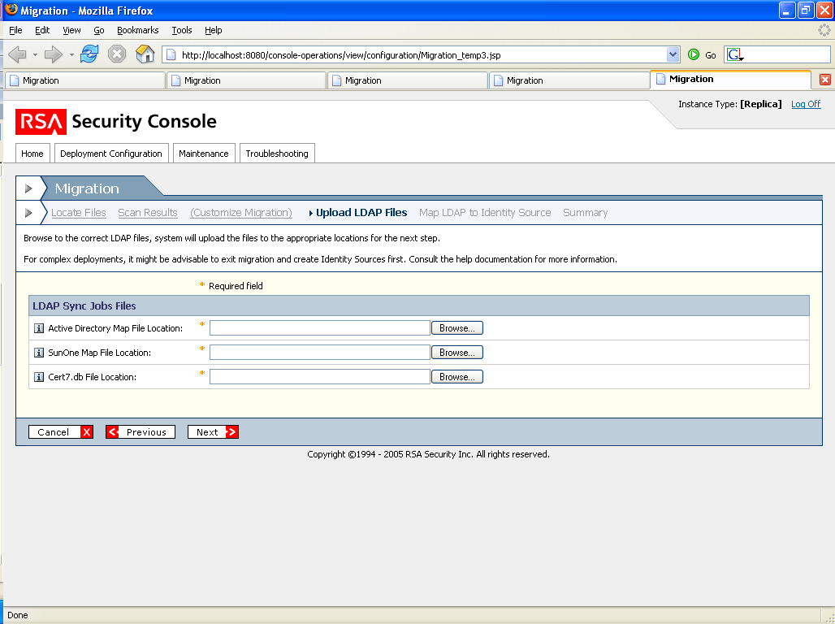

Order | True
Icon | None

RSAConsoleTab | Link | Index
Locate Files | Locate Files | 0
Scan Results | Scan Results | 1
(Customize Migration) | (Customize Migration) | 2
Upload Sync Job Files | Upload Sync Job Files | 3
Map Directory to Identity Source | Map Directory to Identity Source | 4
Summary | Summary | 5

RSAPageHeaderTab
headerImage | icn_server_migration.gif
headerText | Server Migration
pageHelpID | MigrationHelp
showHelp | Y
introText | Browse to select the location of the sync job files. The files will be uploaded so you can map them to identity sources.
Required Field Note? | N

Form Area
RSAGroupHead | LDAP Sync Job Files

Label | Active Directory Map File Location | Component | File Browse
Required? | Y | Enabled? | Y
Value | <User Entry> | Format | <map>
Hint | The map file name is active.map and is located in /utils/toolkit in Authentication Manager 6.1.

Label | Sun ONE Map File Location | Component | File Browse
Required? | Y | Enabled? | Y
Value | <User Entry> | Format | <map>
Hint | The map file name is sunone.map and is located in /utils/toolkit in Authentication Manager 6.1.

-- Removed --
Label | Cert7.db File Location | Component | File Browse
Required? | Y | Enabled? | Y
Value | <User Entry> | Format | <DB>
Hint | The dump file is titled sdserv.lic and can be found in /Data in ACE Sever.

RSAButtonRow – Bottom only
Button Name / Style | Action | Title
Cancel / button_x | Clear contents, go to Home | Cancel
Back / button_lt | Back to Customize Migration | Back
Next / button_gt | Go to Map Directory to Identity Source | Next

Page Specific Error Handling & Messages
Condition | Page top message | Field-level message | Field(s)
Invalid file type. | The file type of the file you provided is invalid. Upload a .map file. | Invalid file type.

Help on this page
Help topics | Link
Perform a Customized Migration | am_customizeMigration.htm

2.5 Map Directory to Identity Source

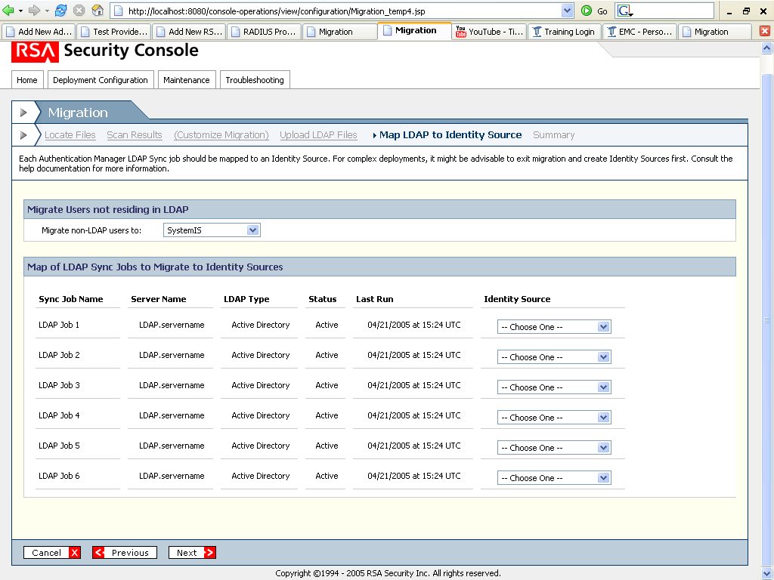

State of Page Design | Draft for Review
URL | http://localhost:8080/console-operations/view/configuration/Migration_temp4.jsp

Revision Date | Description | Revised By
3/31/05 | Initial Draft | Dipankar Roychowdhury
11/20/07 | Updated header icon for server migration | Dipankar Roychowdhury
11/28/07 | Updated the drop down for identity sources, as per bug 69609 | Dipankar Roychowdhury
11/29/07 | Edited introText, inserted Help on this Page topic & link, edited Hint text | Bobbie King
12/27/07 | Updated the topic title in the Help on this page section. | Bobbie King

RSAConsoleWizard

Order | True
Icon | None

RSAConsoleTab | Link | Index
Locate Files | Locate Files | 0
Scan Results | Scan Results | 1
(Customize Migration) | Customize Migration | 2
Upload Sync Job Files | Upload Sync Job Files | 3
Map Directory to Identity Source | Map Directory to Identity Source | 4
Summary | Summary | 5

RSAPageHeaderTab
headerImage | icn_server_migration.gif
headerText | Server Migration
pageHelpID | MigrationHelp
showHelp | Y
introText | Selectively migrates users by matching LDAP sync jobs with identity sources and specifies the identity source to which users not residing in any LDAP directory should be migrated.
Required Field Note? | N

Form Area
RSAGroupHead | Migrate Users not residing in LDAP

Label | Migrate non-LDAP users to |  |  | Component | RSASelectOptions
Multiple? | N | Choose One? | N | Enabled? | Y
Prelabel |  |  |  | Default | Internal Database
Hint | The identity source to which users not in any LDAP directory should be migrated.

RSAGroupHead | Map LDAP Sync Jobs to Identity Sources

Label |  | Component |  | Table
Numer of collumns | 6 |  | Number of rows |  | The number of LDAP sync jobs
Collumn 1 | Sync Job Name
Collumn 2 | Server Name
Collumn 3 | LDAP Type
Collumn 4 | Status
Collumn 5 | Last Run
Collumn 6 | Identity Source

Collumn Name | Sync Job Name |  |  | Component | Text
Type | String | Value | Provided by the backend

Collumn Name | Server Name |  |  | Component | Text
Type | String | Value | Provided by the backend

Collumn Name | LDAP Type |  |  | Component | Text
Type | String | Value | Active Directory, Sun One, etc (Provided by the backend)

Collumn Name | Status |  |  | Component | Text
Type | String | Value | Number of users added (Provided by the backend)

Collumn Name | Last Run |  |  | Component | Text
Type | Date | Date format | mm/dd/yy Hours:Minutes:Seconds AM (Server time zone)
Value | Provided by backend

Collumn Name | Identity Source |  |  | Component | RSASelectOptions
Multiple? | N | Choose One? | Y | Enabled? | Y
Required? | Y |  |  | Default | -- Choose One--
Value | List Only the identity sources that are either unlinked to a realm Or linked to the deafault realm |  |  | Special Case | The drop down also has an option for “Add New Identity Source”
On Mouse Click | Add New Identity Source (takes them to a separate set of screens to create an identity source, the screens are populated with information from the corresponding LDAP, once the steps are completed user is brought to 1.5 with the created IS displayed as selected)

RSAButtonRow – Bottom only
Button Name / Style | Action | Title
Cancel / button_x | Clear contents, go to Home | Cancel
Back / button_lt | Back to Upload Sync Job Files | Back
Next / button_gt | Go to Summary (For Custom Mode) | Next

Page Specific Error Handling & Messages

NOTE: IF atleast one of the LDAP sync jobs is not supported

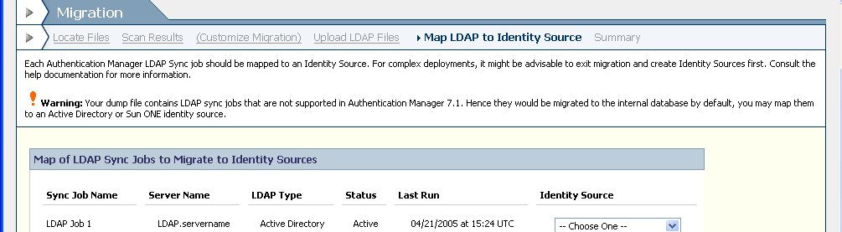

Condition | Page top message | Field-level message | Field(s)
At least one of the LDAP sync jobs to migrate is not supported in Ganymede | “Warning: Your dump file contains LDAP sync jobs that are not supported in Authentication Manager 7.1. Hence they would be migrated to the internal database by default, you may map them to an Active Directory or Sun ONE identity source.”  (see screenshot above, display in the introtext)

Help on this page
Help topics | Link
Perform a Customized Migration | am_customizeMigration.htm

Next steps | Link
View Summary | MigrationSummary_temp.jsp

2.6 Summary (For Typical Mode)

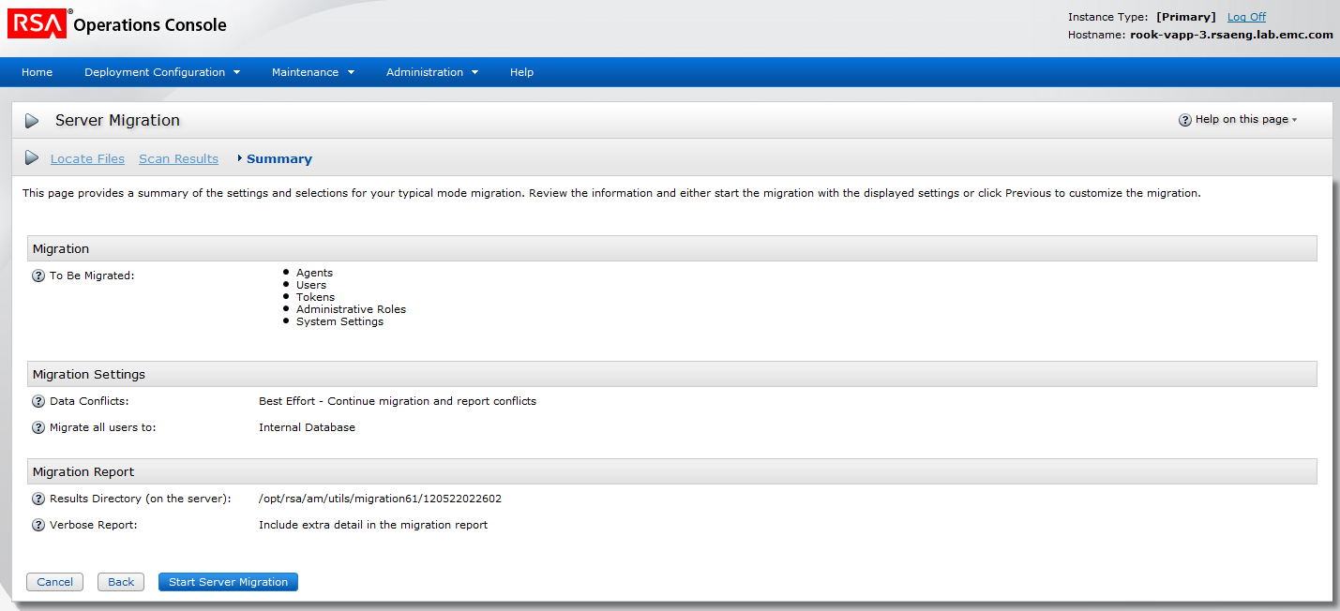

State of Page Design | Draft for Review
URL | http://localhost:8080/console-operations/view/configuration/MigrationSummary_temp.jsp

Revision Date | Description | Revised By
7/11/07 | Initial Draft | Dipankar Roychowdhury
11/20/07 | Updated header icon for server migration | Dipankar Roychowdhury
11/29/07 | Edited introText, inserted Help on this Page topic & link, deleted Hint text for Summary fields, edited Hint text on one summary field. | Bobbie King
12/5/07 | Updated To Be Migrated section for Protect IP addess of auto-registered agents as per bug 70678 | Dipankar Roychowdhury
12/27/07 | Updated the topic title in the Help on this page section. | Bobbie King

RSAConsoleWizard

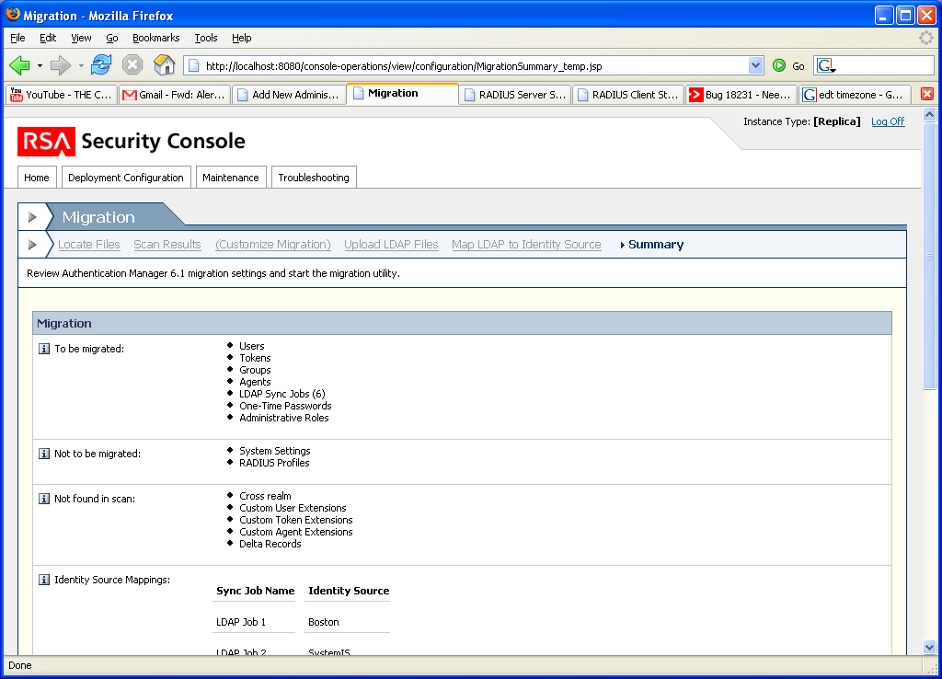

Order | True
Icon | None

RSAConsoleTab | Link | Index
Locate Files | Locate Files | 0
Scan Results | Scan Results | 1
Summary | Summary | 2

RSAPageHeaderTab
headerImage | icn_server_migration.gif
headerText | Server Migration
pageHelpID | MigrationHelp
showHelp | Y
introText | This page provides a summary of the settings and selections for your typical mode migration. Review the information and either start the migration with the displayed settings or click Back to customize the migration.  <Warning> LDAP sync jobs were found in the dump file. Typical mode migrates all users, including those in the sync jobs to the internal database only.</warning> (display if sync jobs are present in the dump yet user chooses typical mode)
Required Field Note? | N

Form Area
RSAGroupHead | Migration

Label | To Be Migrated | Component | RSARow
Value | Provided by backend (bullets)
Special Case | For Agents, if the Protect IP addess checkbox was selected on the Customize migration screen, show the bullet as:  Agents (Protect the IP address of all agents including the agents that auto-registered with the system)
Hinttext

RSAGroupHead | Migration Settings

Label | Test Migration | Component | RSACheckBox
Default State | Read Only | Enabled? | Y
Prelabel | N/A | Postlabel | Create output report without performing actual migration: No
Hint | Check to perform a test migration and verify if migration would be successfull. System will produce reports and results indicating the affects of an actual migration

Label | Data Conflicts | Component | RSAMultiRadios
Default State | Read Only | Enabled? | Y
Prelabel | N/A | Postlabel | Best Effort - Continue migration and report conflicts
Hint | In the event of data conflicts, Best Effort continues the migration and describes the data conflicts in the migration report. No Conflict stops the migration and describes the data conflicts in a report.

Label | Migrate all users to | Component | RSARow
Value | Internal Database
Hinttext | Have the system create all users in Internal Database

Label | User ID Format | Component | RSACheckBox
Default State | Read Only | Enabled? | Y
Prelabel | N/A | Postlabel | For users migrated to Internal Database convert User ID from NTLM to UPN format: No
Hint | For users migrated into SystemIS you can choose to convert their login ID from NTLM to UPN format

Label | Migrate into Sub-Domain |  |  | Component | RSASelectOptions
Default State | Read Only | Choose One? | N | Enabled? | Y
 |  |  |  | Post Label | Migrate directly into sub-domain: SystemDomain
Hint | Migrate users into the selected security domain.

Label | Migration Retry Cleanup | Component | RSARow
Value | Enabled (if checkbox under “Migration Retry Cleanup” section on Scan Results page was checked)  Disabled (if checkbox under “Migration Retry Cleanup” section on Scan Results page was checked)
Hinttext | Prepares the system for a migration retry by clearing the mapping table from the previous attempt.

RSAGroupHead | Migration Report

Label | Results Directory (on the server) | Component | RSARow
Value | [standard directory location] | Enabled? | Y
Hint | "Specifies the location of the migration results. The directory is on the same machine as primary Authentication Manager server. "

Label | Verbose Report | Component | RSACheckBox
Default State | Read Only | Enabled? | Y
Prelabel | N/A | Postlabel | Include extra detail in the migration report: No
Hint | Report will have migration details for all migrated objects. eg: users. Tokens, agents, etc.

RSAButtonRow – Bottom only
Button Name / Style | Action | Title
Cancel / button_x | Clear contents, go to Home | Cancel
Back / button_lt | Back to Scan Results | Back
Start Migration / button_gt | Go to Migration Status | Start Migration

Page Specific Error Handling & Messages
Condition | Page top message | Field-level message | Field(s)

Help on this page
Help topics | Link
Perform a Typical Mode or Rolling Upgrade Migration | am_TypicalMigration.htm
Perform a Customized Migration

2.7 Summary (For Custom Mode)

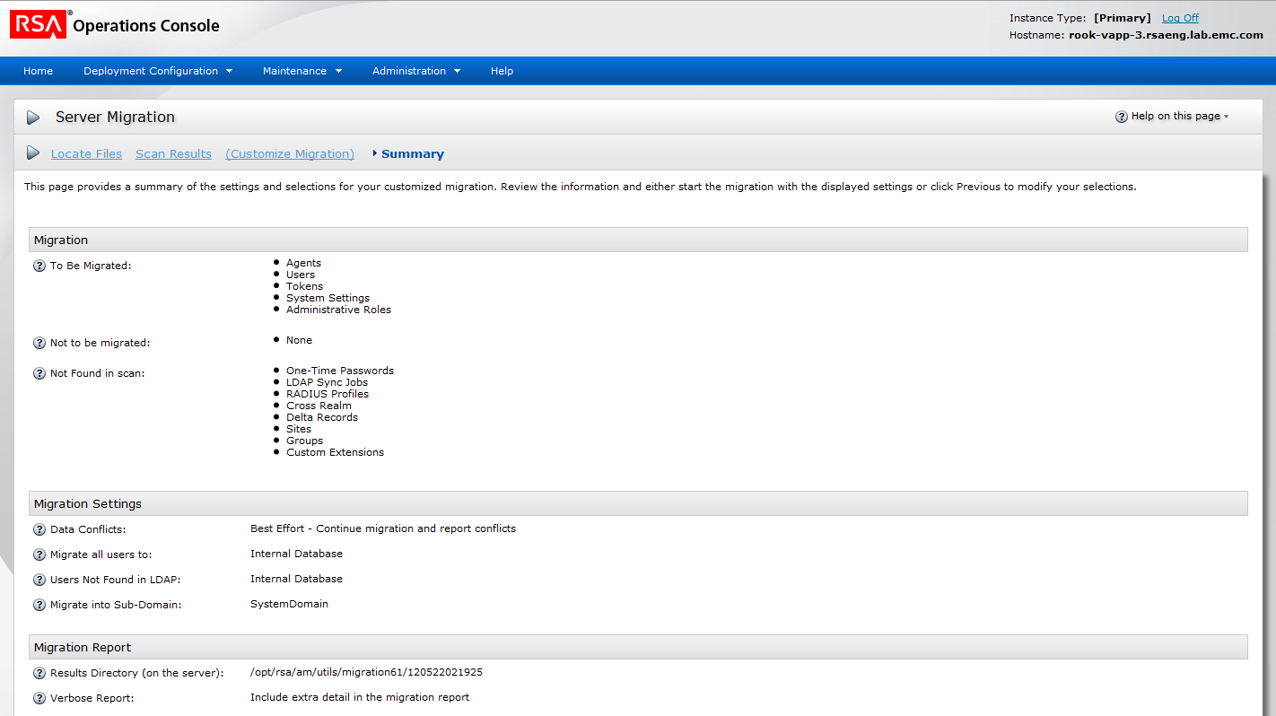

State of Page Design | Draft for Review
URL | http://localhost:8080/console-operations/view/configuration/MigrationSummary_temp.jsp

Revision Date | Description | Revised By
6/28/07 | Initial Draft | Dipankar Roychowdhury
11/20/07 | Updated header icon for server migration | Dipankar Roychowdhury
11/29/07 | Edited introText, inserted Help on this Page topic & link, deleted Hint text for Summary fields, edited Hint text on one summary field. | Bobbie King
12/28/07 | Updated topic title in Help on this page section. | Bobbie King

RSAConsoleWizard

Order | True
Icon | None

RSAPageHeaderTab
headerImage | icn_server_migration.gif
headerText | Server Migration
pageHelpID | MigrationHelp
showHelp | Y
introText | This page provides a summary of the settings and selections for your customized migration. Review the information and either start the migration with the displayed settings or click Back to modify your selections.
Required Field Note? | N

Form Area
RSAGroupHead | Migration

Label | To Be Migrated | Component | RSARow
Value | provided by backend
Format | Bullets
Hinttext | These components will be migrated

Label | Not to be Migrated | Component | RSARow
Value | Provided by backend
Format | Bullets
Hinttext | These components were found in the scan and were selected to not migrate.

Label | Not Found in Scan | Component | RSARow
Value | Provided by backend
Format | Bullets
Hinttext | These are the components supported by Authentication Manager that were not discovered in the dump file provided.  To migrate these components, create a new dump file with these components.

Label | Identity Source Mappings | Component |  | Table
Numer of collumns | 2 |  | Number of rows |  | The number of LDAP sync jobs
Enabled | Y (Only if the choice for User Migration on 12.1.3 was Selectively migrate users to appropriate identity sources)
Collumn 1 | Sync Job Name
Collumn 2 | Identity Source

Collumn Name | Sync Job Name |  |  | Component | Text
Type | String | Value | Provided by the backend

Collumn Name | Identity Source |  |  | Component | Text
Type | String | Value | Provided by the backend

RSAGroupHead | Migration Settings

Label | Test Migration | Component | RSACheckBox
Default State | Read Only | Enabled? | Y
Prelabel | N/A | Postlabel | Create output report without performing actual migration: Yes/No (based on choice made at 1.2.1.3)
Hint | Check to perform a test migration and verify if migration would be successfull. System will produce reports and results indicating the affects of an actual migration

Label | Data Conflicts | Component | RSAMultiRadios
Default State | Read Only | Enabled? | Y
Prelabel | N/A | Postlabel | Best Effort - Continue migration and report conflicts or No Conflict – Stop migration on data conflict (based on choice made at 1.2.1.3)
Hint | In the event of data conflicts  Best Conflict will refer system settings to resolve the conflict and describe it in the report.  No Conflict will stop migration and describe the conflict in the report

Label | Migrate Users to | Component | RSAMultiRadios
Default State | Read Only | Enabled? | Y
Prelabel | N/A | Postlabel | Internal Database or [IS selected in 1.2.1.3] or Selected identity sources.
Hint | You can choose to...  1. Have the system create all users in Internal Database  2. Have system confirm that the users in the dump file are present in the target identity source. The users that were not found in the target IS can be discarded or created in Internal Database  3. You can create a mapping of sync jobs to identity sources at a later step and have the system confirm that users in the sync job are present in the target identity source. The users that were not found in the target IS can be discarded or created in Internal Database

Label |  | Component | RSACheckBox
Default State | Read Only | Enabled? | Y
Prelabel | N/A | Postlabel | For users in dump file that were not found in the target identity source, move them to Internal Database: Yes/No (based on choice made at 1.2.1.3)
Not Row | True
Hide/Show | Show if the radio option for “Migrate users to the Identity source” or “Selectively migrate users to appropriate identity sources” was selected on 1.3

Label | User ID Format | Component | RSACheckBox
Default State | Read Only | Enabled? | Y
Prelabel | N/A | Postlabel | For users migrated to Internal Database convert User ID from NTLM to UPN format: Yes/No (based on choice made at 1.2.1.3)
Hint | For users migrated into SystemIS you can choose to convert their login ID from NTLM to UPN format

Label | Migrate into Sub-Domain |  |  | Component | RSASelectOptions
State | Read Only | Choose One? | N | Enabled? | Y
 |  |  |  | Post Label | Migrate directly into sub-domain: [Security domain selected at 1.3]
Hint | Migrate users into the selected security domain.

Label | Migration Retry Cleanup | Component | RSARow
Value | Enabled (if checkbox under “Migration Retry Cleanup” section on Scan Results page was checked)  Disabled (if checkbox under “Migration Retry Cleanup” section on Scan Results page was checked)
Hinttext | Prepares the system for a migration retry by clearing the mapping table from the previous attempt.

Label | Replace Unsupported Characters | Component | RSARow
Value | Enabled (if checkbox under “Migration Settings” section on Customize migration page was checked)  Disabled (if not checked)
Hinttext | For security purposes, the HTML-based consoles in version 8.0 do not support certain characters. Use this feature to automatically replace the unsupported characters < > & % ` found in the dump file with + { } / ' . Because this changes the migrated data, RSA recommends that you perform a test migration to identify the specific records containing unsupported characters and manually update them before migration

RSAGroupHead | Migration Report

Label | Results Directory (on the server) | Component | RSARow
Value | [standard directory location] | Enabled? | Y
Hint | "Specifies the location of the migration results. The directory is on the same machine as primary Authentication Manager server. "

Label | GZIP Output | Component | RSACheckBox
Default State | Read Only | Enabled? | Y
Prelabel | N/A | Postlabel | GZIP each output file
Hint | GZIP output file for deployments with a lot of objects, when you expect the file size to be large
Hide/Show | Only show if GZIP Output is enabled

Label | Verbose Report | Component | RSACheckBox
Default State | Read Only | Enabled? | Y
Prelabel | N/A | Postlabel | Include extra detail in the migration report: Yes/No (based on choice made at 1.2.1.3)
Hint | Report will have migration details for all migrated objects. eg: users. Tokens, agents, etc.

RSAButtonRow – Bottom only
Button Name / Style | Action | Title
Cancel / button_x | Clear contents, go to Home | Cancel
Back/ button_lt | Back to Customize Migration | Back
Start Server Migration / button_gt or  Start Test Migration/ button_gt if test migration was selected | Go to Migration Status  Go to Test Migration Status (if test migration was selected) | Start Migration or Start Test Migration (if test migration was selected)

Page Specific Error Handling & Messages
Condition | Page top message | Field-level message | Field(s)

Help on this page
Help topics | Link
Perform a Typical Mode or Rolling Upgrade Migration
Perform a Customized Migration

2.8 Summary (For Rolling Upgrade Mode)

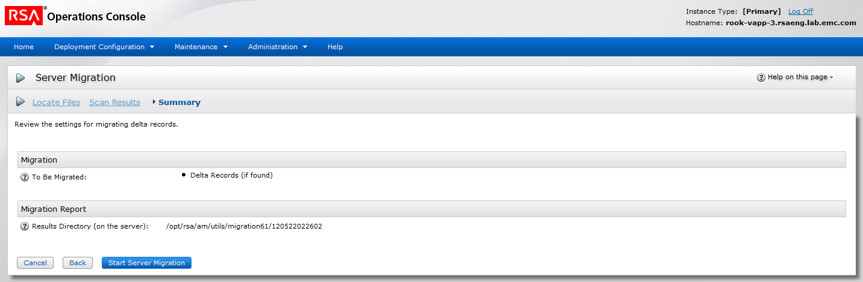

State of Page Design | Draft for Review
URL | http://localhost:8080/console-operations/view/configuration/MigrationSummary_temp.jsp

Revision Date | Description | Revised By
7/11/07 | Initial Draft | Dipankar Roychowdhury
11/20/07 | Updated based on bug 63573 and 98672 | Dipankar Roychowdhury

RSAConsoleWizard

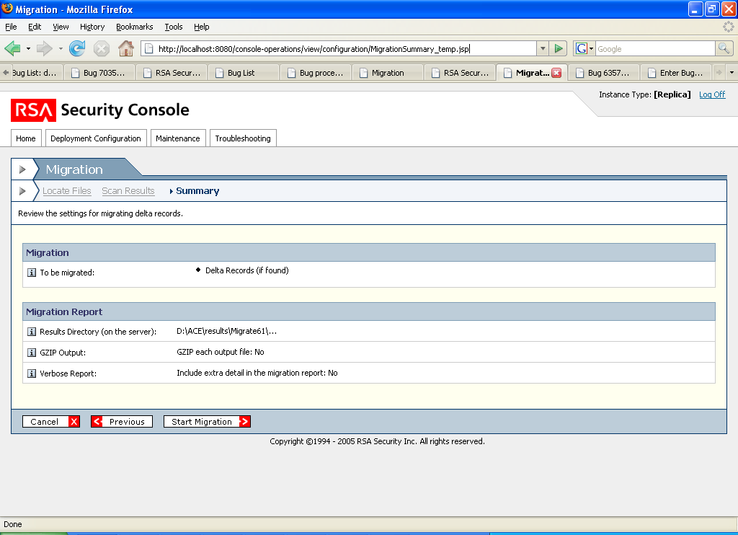

Order | True
Icon | None

RSAConsoleTab | Link | Index
Locate Files | Locate Files | 0
Scan Results | Scan Results | 1
Summary | Summary | 2

RSAPageHeaderTab
headerImage | icn_server_migration.gif
headerText | Server Migration
pageHelpID | MigrationHelp
showHelp | Y
introText | Review the settings for migrating delta records.
Required Field Note? | N

Form Area
RSAGroupHead | Migration

Label | To Be Migrated | Component | RSARow
Value | If pre-migration scan detect delta records, display “Delta Records”  If pre migration did not detect delta records but user selected rolling upgrade display “Delta Records (if found)”
Hinttext

RSAGroupHead | Migration Settings

Label | Migration Retry Cleanup | Component | RSARow
Value | Enabled (if checkbox under “Migration Retry Cleanup” section on Scan Results page was checked)  Disabled (if checkbox under “Migration Retry Cleanup” section on Scan Results page was checked)
Hinttext | Prepares the system for a migration retry by clearing the mapping table from the previous attempt.

RSAGroupHead | Migration Report

Label | Results Directory (on the server) | Component | RSARow
Value | [standard directory location] | Enabled? | Y
Hint | "Specifies the location of the migration results. The directory is on the same machine as primary Authentication Manager server. "

RSAButtonRow – Bottom only
Button Name / Style | Action | Title
Cancel / button_x | Clear contents, go to Home | Cancel
Back / button_lt | Back to Scan Results | Back
Start Migration / button_gt | Go to Migration Status | Start Migration

Page Specific Error Handling & Messages
Condition | Page top message | Field-level message | Field(s)

Help on this page
Help topics | Link
Perform a Typical Mode or Rolling Upgrade Migration | am_TypicalMigration.htm

Next steps | Link
Migration in progress | Migration_temp6.jsp

2.9 Migration Status

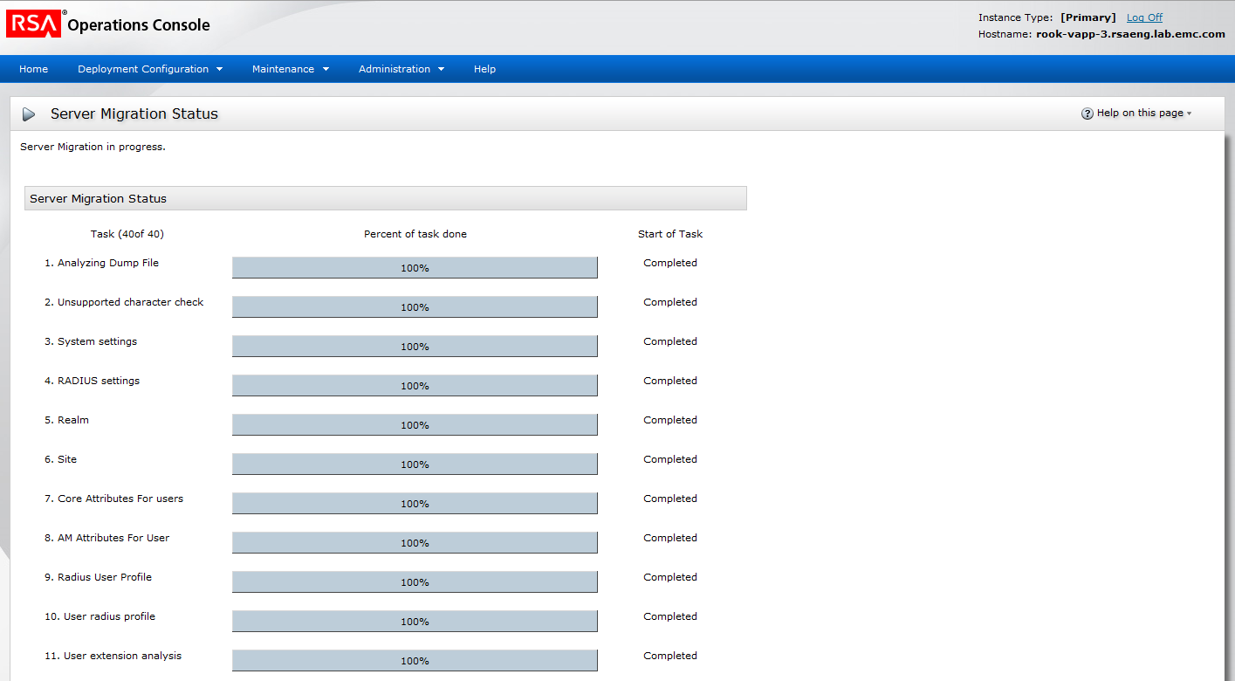

State of Page Design | Draft for Review
URL | http://localhost:8080/console-operations/view/configuration/Migration_temp6.jsp

Revision Date | Description | Revised By
6/28/07 | Initial Draft | Dipankar Roychowdhury
11/8/07 | Updated screenshot and description for the changes made to the screen (added progress bar) as per bug 69631 | Dipankar Roychowdhury
11/20/07 | Updated header icon for server migration | Dipankar Roychowdhury
11/29/07 | Inserted Help on this Page topics & links | Bobbie King
12/28/07 | Updated topic titles in Help on this page section. | Bobbie King

RSAPageHeaderTab
headerImage | icn_server_migration.gif
headerText | Server Migration Status
pageHelpID | MigrationHelp
showHelp | Y
introText | Server migration in progress.
Required Field Note? | N

Form Area
RSAGroupHead | Server Migration Status

Label |  | Component |  | Table
Numer of columns | 3 |  | Number of rows |  | One row for every object migrated. Number and name of the task followed by the progress bar in the row indicating the task progress followed by time of start (if task completed then Completed instead of the time).
Enabled | Y
Column 1 | Task (Number of current task/ total number of tasks in migration)
Column 2 | Percent of task done
Column 3 | Start of Task

Column Name | Task (Number of current task/ total number of tasks in migration) |  |  | Component | Text
Type | String | Value | Name of the current task (provided by the backend)

Column Name | Percent of task done |  |  | Component | Progress bar
Type | 0 -100 % | Value | provided by the backend

Column Name | Start of Task |  |  | Component | Text
Type | Date | Date format | mm/dd/yy Hours:Minutes AM (Server time zone)
Value | Provided by backend (indicates start time for the current task)  If task complete, value is “Completed”  If task not started value is “Not Started”

Note: The page also auto refreshes every second.

RSAButtonRow – Bottom only
Button Name / Style | Action | Title
Cancel Migration / button_x | Clear contents, go to Home | Cancel Migration
Refresh / button_r | Refresh the page | Refresh

Page Specific Error Handling & Messages
Condition | Page top message | Field-level message | Field(s)

Help on this page
Help topics | Link
Perform a Typical Mode or Rolling Upgrade Migration | am_TypicalMigration.htm
Perform a Customized Migration | am_customizeMigration.htm

2.10 Migration Results

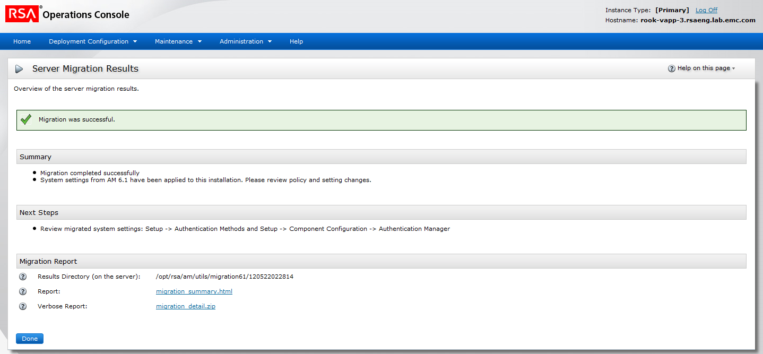

State of Page Design | Draft for Review
URL | http://localhost:8080/console-operations/view/configuration/MigrationSummary_temp.jsp

Revision Date | Description | Revised By
6/28/07 | Initial Draft | Dipankar Roychowdhury
10/30/07 | Added a row for Verbose Report based on bug 70685 | Dipankar Roychowdhury
11/20/07 | Updated header icon for server migration | Dipankar Roychowdhury
11/29/07 | Inserted Help on this Page topics & links, edited Hint text, inserted question in comment | Bobbie King
12/28/07 | Made some minor edits in Hint and intro text; updated topic titles in Help on this page section. | Bobbie King

RSAPageHeaderTab
headerImage | icn_server_migration.gif
headerText | Server Migration Results
pageHelpID | MigrationHelp
showHelp | Y
introText | Overview of the server migration results.
Required Field Note? | N

Form Area

Confirmation Messages
Condition | Message
Migration complete | Depening on the results the text displayed would be “Migration was successful” or “Migration was successful with warnings” or “Migration failed, please review the errors reported”
Format | Display color of the confirmation message would depend if it is confirmation, warning or error message.

RSAGroupHead | Summary

Label |  | Component | RSAText
 |  | Styleclass | simpleRow
Value | [Provided by the backend] | Enabled? | Y

RSAGroupHead | Next Steps

Label |  | Component | RSAText
Value | [Provided by the backend] | Enabled? | Y
Value by Default | [Provided by the backend]
Format | Bullets

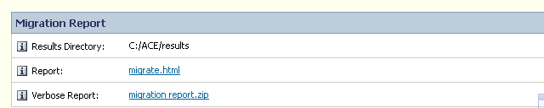

RSAGroupHead | Migration Report

Label | Results Directory (on the server) | Component | RSARow
Value | [standard directory location] | Enabled? | Y
Hint | "Specifies the location of the migration results. The directory is on the same machine as the Authentication Manager primary server. "

Label | Report | Component | RSARow
Value | [Link to migration report] | Enabled? | Y
Hint | The migration report provides information about the migrated data.

Label | Verbose Report | Component | RSARow
Value | [Link to verbose report] | Enabled? | Y
Hint | The verbose report provides detailed information about the migrated data.
Hide/Show | Displayed only if the Verbose Report option is selected on the Customize migration screen (1.2.1.3)

RSAButtonRow – Bottom only
Button Name / Style | Action | Title
Done / button_gt | Go to Home | Done

Page Specific Error Handling & Messages
Condition | Page top message | Field-level message | Field(s)

Help on this page
Help topics | Link
Perform a Typical Mode or Rolling Upgrade Migration
Perform a Customized Migration

2.11 Test Migration Status

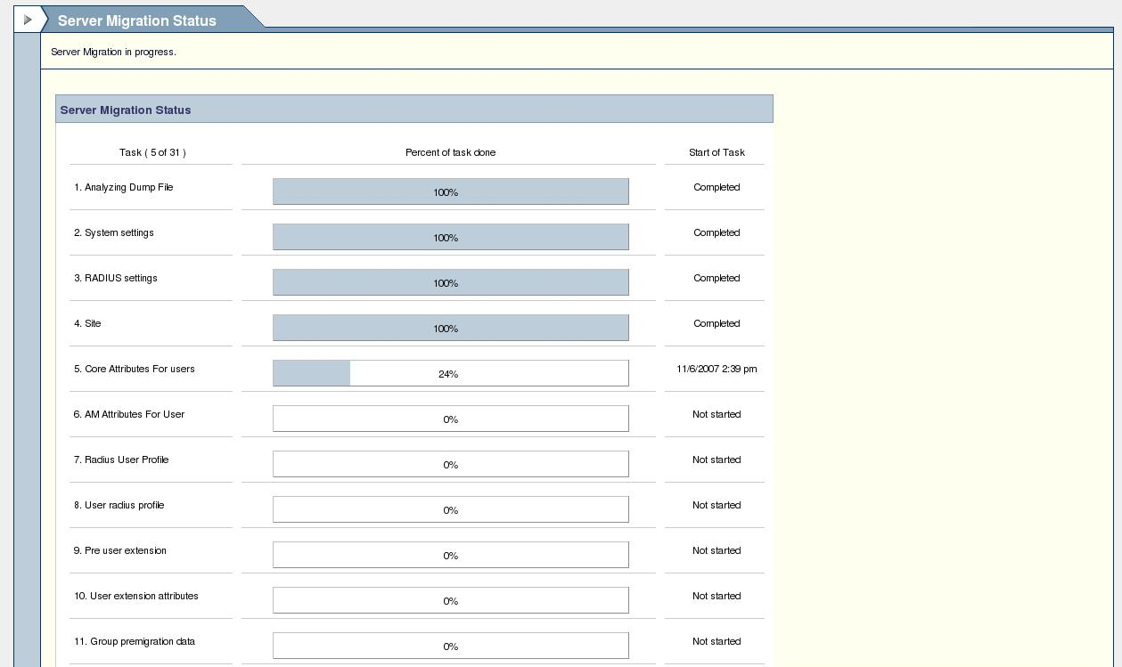

State of Page Design | Draft for Review
URL | http://localhost:8080/console-operations/view/configuration/Migration_temp6.jsp

Revision Date | Description | Revised By
6/28/07 | Initial Draft | Dipankar Roychowdhury
11/8/07 | Updated screenshot and description for the changes made to the screen (added progress bar) as per bug 69631 | Dipankar Roychowdhury
11/20/07 | Updated header icon for server migration | Dipankar Roychowdhury
11/29/07 | Inserted Help on this Page topic & link | Bobbie King
12/28/07 | Updated topic title in the Help on this page section. | Bobbie King

RSAPageHeaderTab
headerImage | icn_server_migration.gif
headerText | Test Server Migration Status
pageHelpID | MigrationHelp
showHelp | Y
introText | Test server migration in progress.
Required Field Note? | N

Form Area
RSAGroupHead | Test Server Migration Status

Label |  | Component |  | Table
Numer of collumns | 3 |  | Number of rows |  | One row for every object migrated. Number and name of the task followed by the progress bar in the row indicating the task progress followed by time of start (if task completed then Completed instead of the time).
Enabled | Y
Collumn 1 | Task (Number of current task/ total number of tasks in migration)
Collumn 2 | Percent of task done
Collumn 3 | Start of Task

Collumn Name | Task (Number of current task/ total number of tasks in migration) |  |  | Component | Text
Type | String | Value | Name of the current task (provided by the backend)

Collumn Name | Percent of task done |  |  | Component | Progress bar
Type | 0 -100 % | Value | provided by the backend

Collumn Name | Start of Task |  |  | Component | Text
Type | Date | Date format | mm/dd/yy Hours:Minutes AM (Server time zone)
Value | Provided by backend (indicates start time for the current task)  If task complete, value is “Completed”  If task not started value is “Not Started”

Note: The page also auto refreshes every second.

RSAButtonRow – Bottom only
Button Name / Style | Action | Title
Cancel Migration / button_x | Clear contents, go to Home | Cancel Migration
Refresh / button_r | Refresh the page | Refresh

Page Specific Error Handling & Messages
Condition | Page top message | Field-level message | Field(s)

Help on this page
Help topics | Link
Perform a Typical Mode or Rolling Upgrade Migration
Perform a Customized Migration

2.12 Test Migration Results

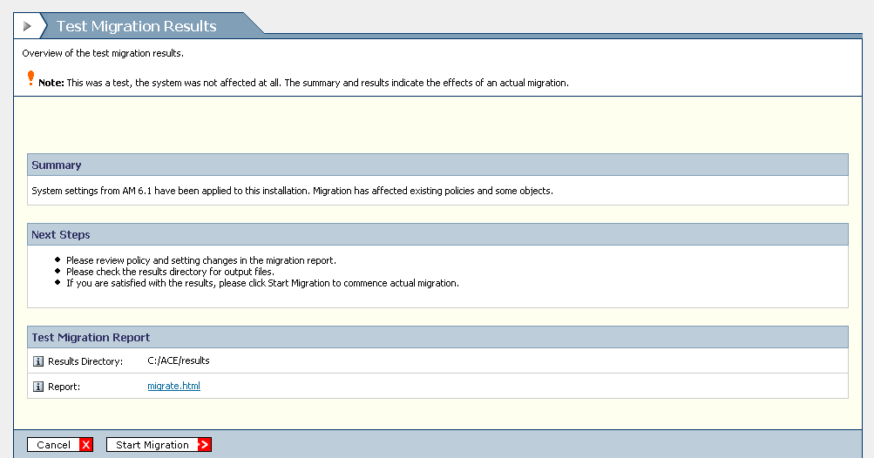

State of Page Design | Draft for Review
URL | http://localhost:8080/console-operations/view/configuration/Migration_results.jsp

Revision Date | Description | Revised By
6/28/07 | Initial Draft | Dipankar Roychowdhury
10/30/07 | Added a row for Verbose Report based on bug 70685 | Dipankar Roychowdhury
11/20/07 | Updated header icon for server migration | Dipankar Roychowdhury
11/29/07 | Edited introText, inserted Help on this Page topic & link, edited Hint text , inserted question in comment. | Bobbie King
12/28/07 | Made a few edits in hint and into text and updated the topic title in the Help on this page section. | Bobbie King

RSAPageHeaderTab
headerImage | icn_server_migration.gif
headerText | Test Server Migration Results
pageHelpID | MigrationHelp
showHelp | Y
introText | Overview of test server migration results.  <warning icon>Note: These results represent a test migration only; your system was not affected in any way. The summary and results indicate what the outcome of a potential migration would be.
Required Field Note? | N

Form Area

Confirmation Messages
Condition | Message
Migration complete | Depending on the results, the text displayed would be “Test Migration was successful” or “Test Migration was successful with warnings” or “Test Migration failed, please review the errors reported”
Format | Display color of the confirmation message would depend if it is confirmation, warning or error message.

RSAGroupHead | Summary

Label |  | Component | RSAText
 |  | Styleclass | simpleRow
Value | [Provided by the backend] | Enabled? | Y

RSAGroupHead | Next Steps

Label |  | Component | RSAText
Value | [Provided by the backend] | Enabled? | Y
Format | Bullets

RSAGroupHead | Test Migration Report

Label | Results Directory (on the server) | Component | RSARow
Value | [standard directory location] | Enabled? | Y
Hint | "Specifies the location of the migration results. The directory is on the same machine as the Authentication Manager primary server. "

Label | Report | Component | RSARow
Value | [Link to migration report] | Enabled? | Y
Hint | The migration report provides information about the migrated data.

Label | Verbose Report | Component | RSARow
Value | [Link to verbose report] | Enabled? | Y
Hint | The verbose report provides detailed information about the migrated data.
Hide/Show | Displayed only if the Verbose Report option is selected on the Customize migration screen (1.2.1.3)

RSAButtonRow – Bottom only
Button Name / Style | Action | Title
Start Server Migration / button_gt | Go to Migration Status | Start Migration
Cancel / button_x | Clear contents, go to Home | Cancel

Page Specific Error Handling & Messages
Condition | Page top message | Field-level message | Field(s)

Help on this page
Help topics | Link
Perform a Typical Mode or Rolling Upgrade Migration
Perform a Customized Migration

